Step 1: open a browser and search JDK 11 download for windows

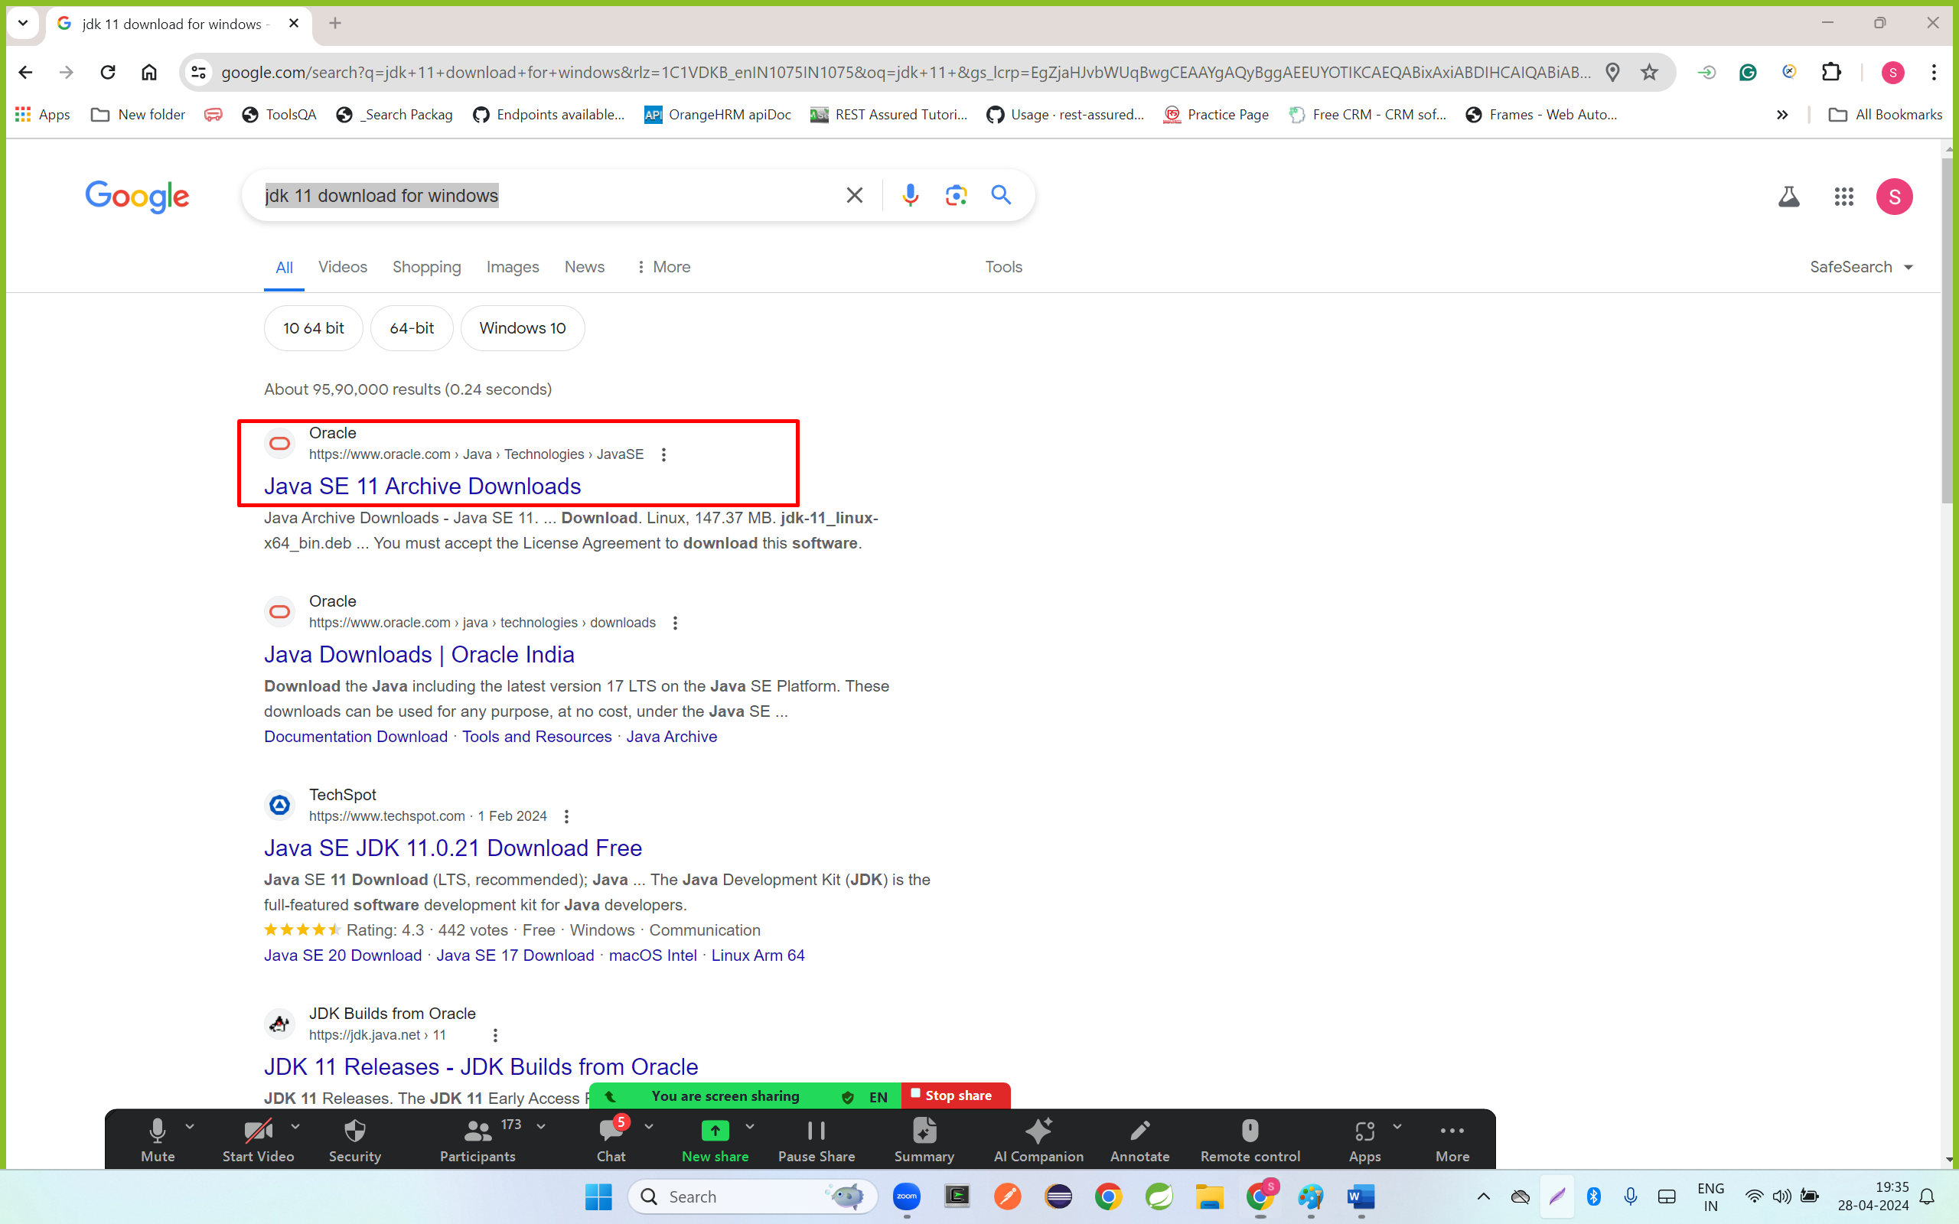

Step2: open a **URL** <https://www.oracle.com/in/java/technologies/javase/jdk11-archive-downloads.html>

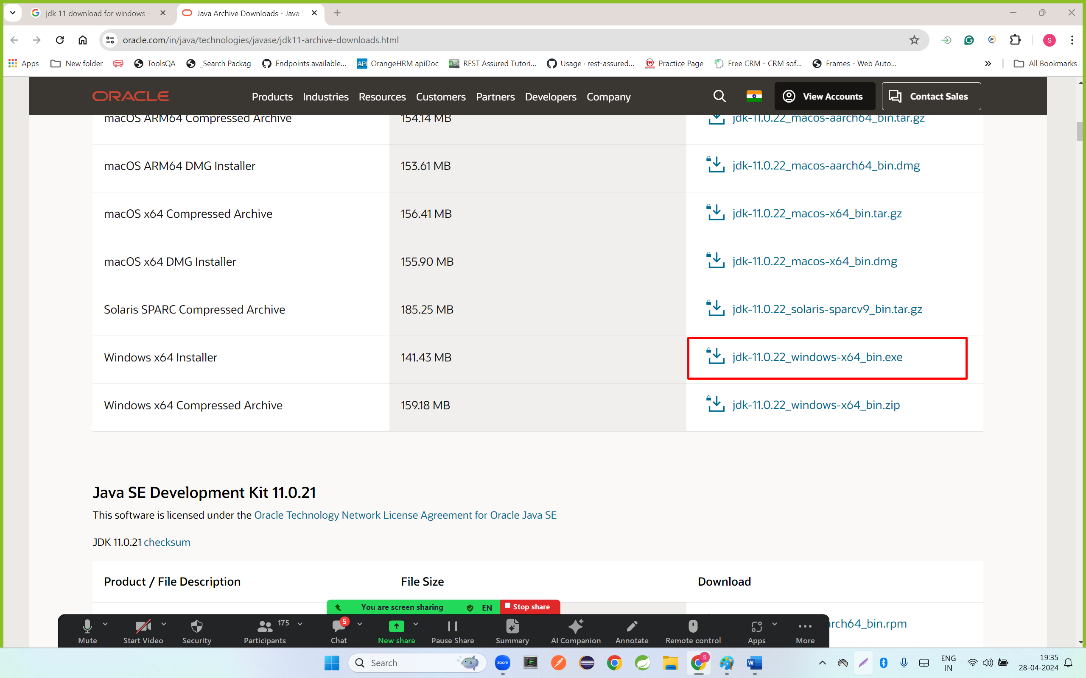

Step 3:select the checkbox and click on download

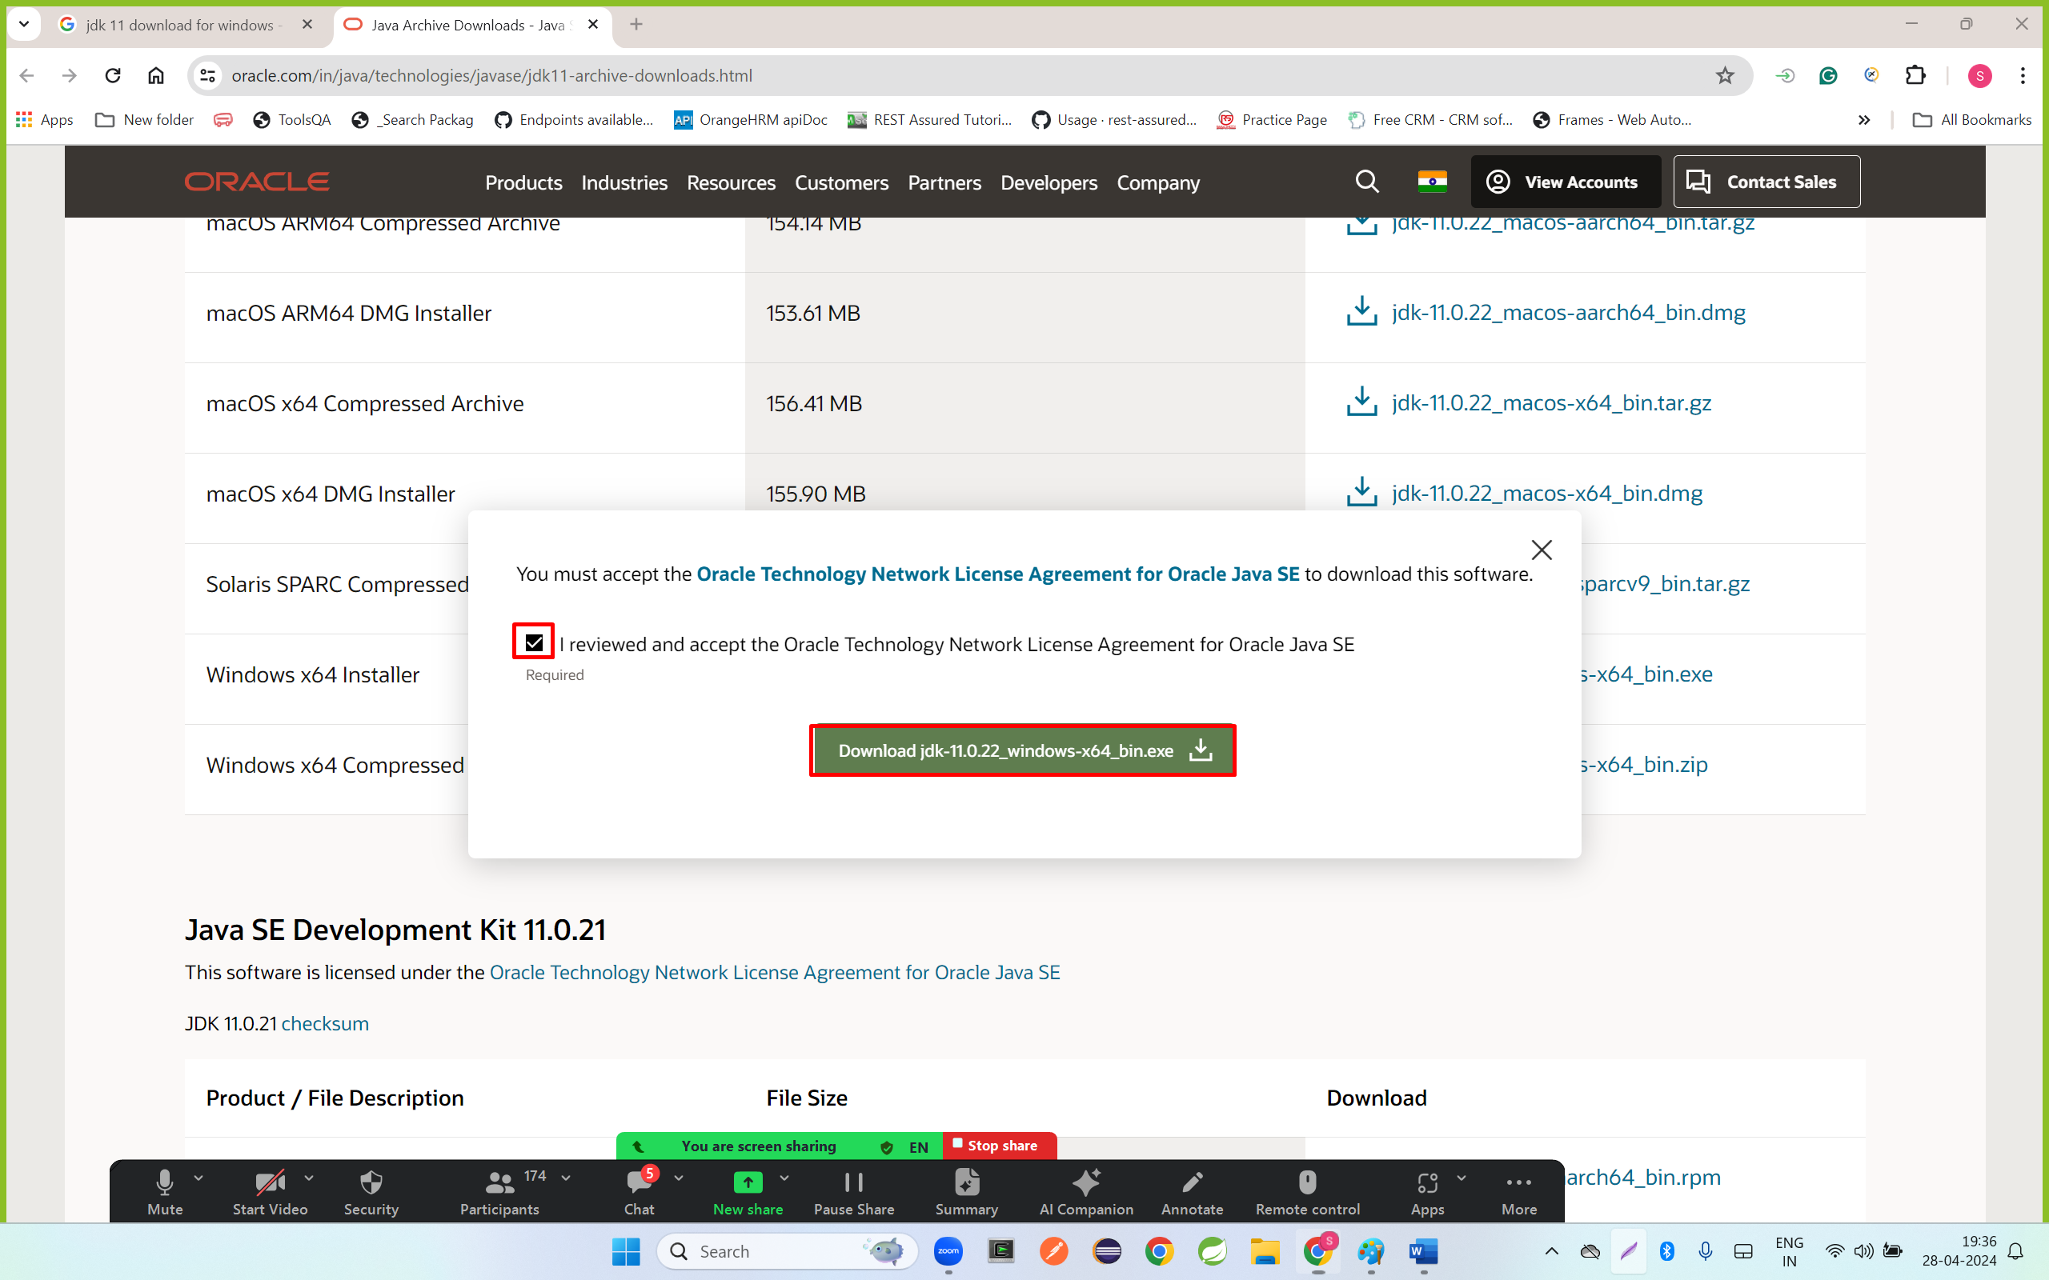

Step 4: open Download folder in laptop and double click on downloaded file

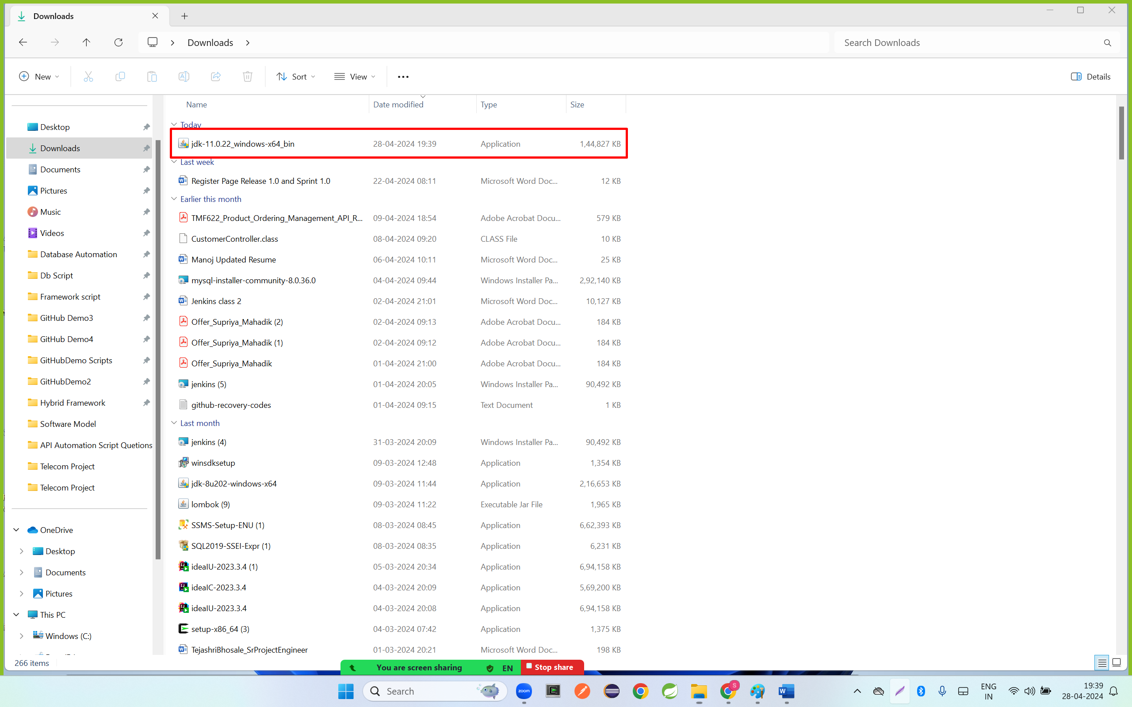

Step 5: click on next button

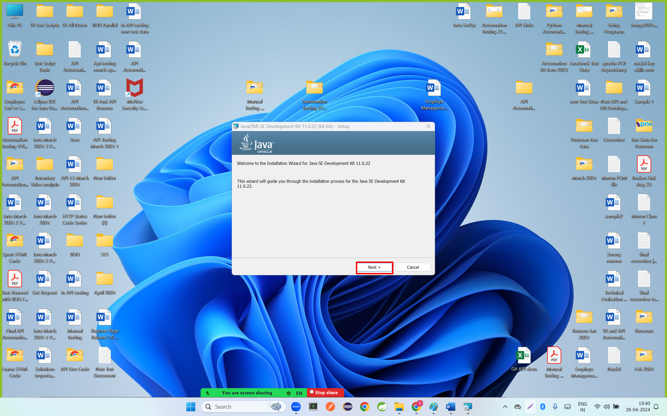

Step 6: click on next button

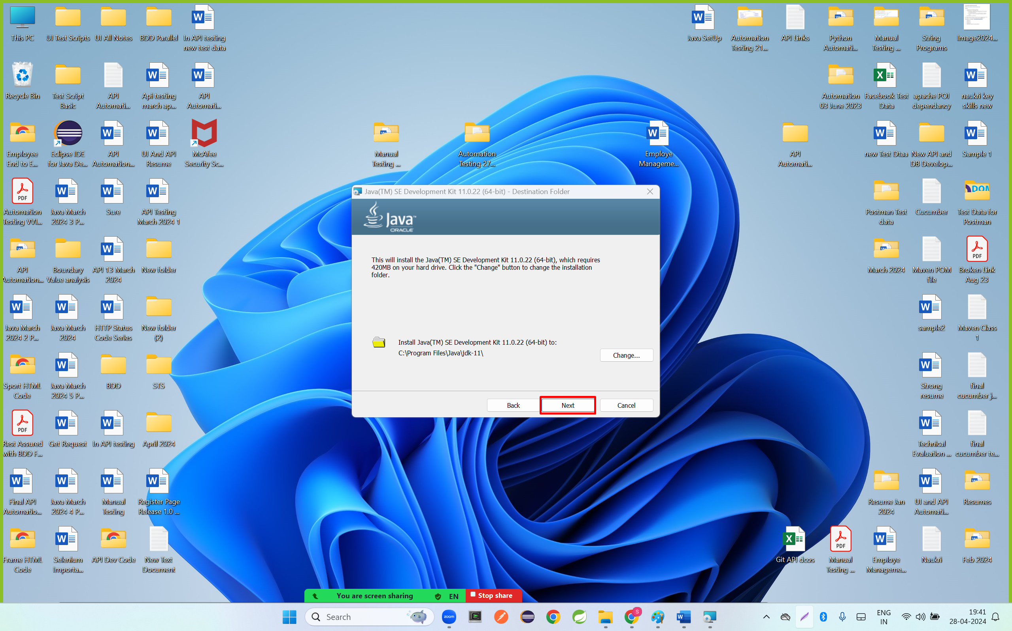

Step 7: click on close

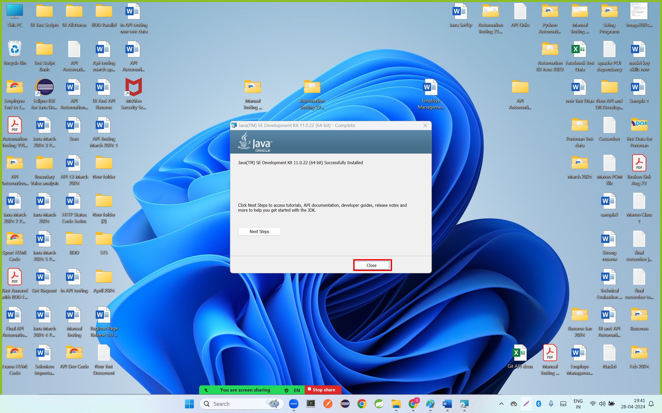

Install Eclipse IDE

Step 1: open browser and search eclipse ide download for windows 10

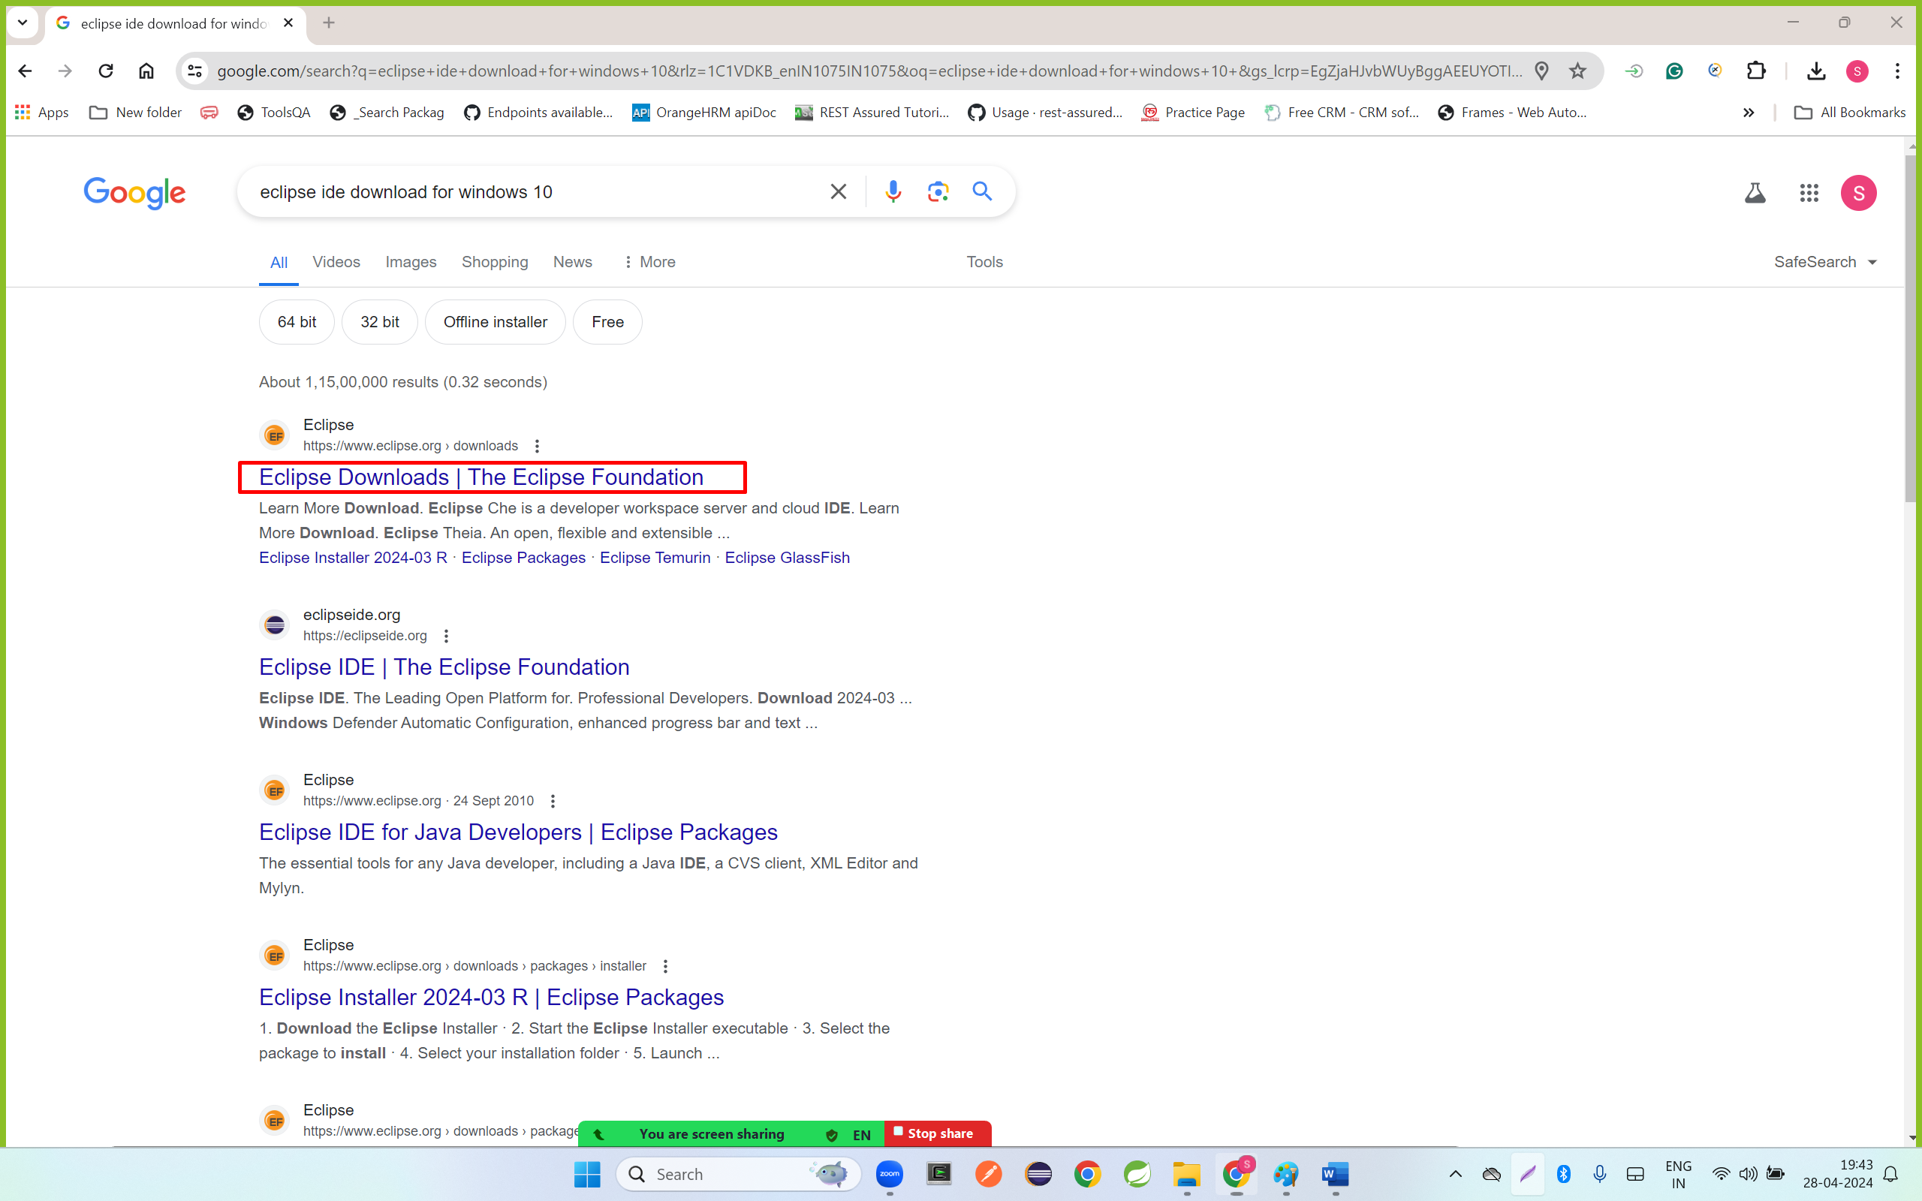

Step 2: open a URL <https://www.eclipse.org/downloads/>

And click on downloaded button

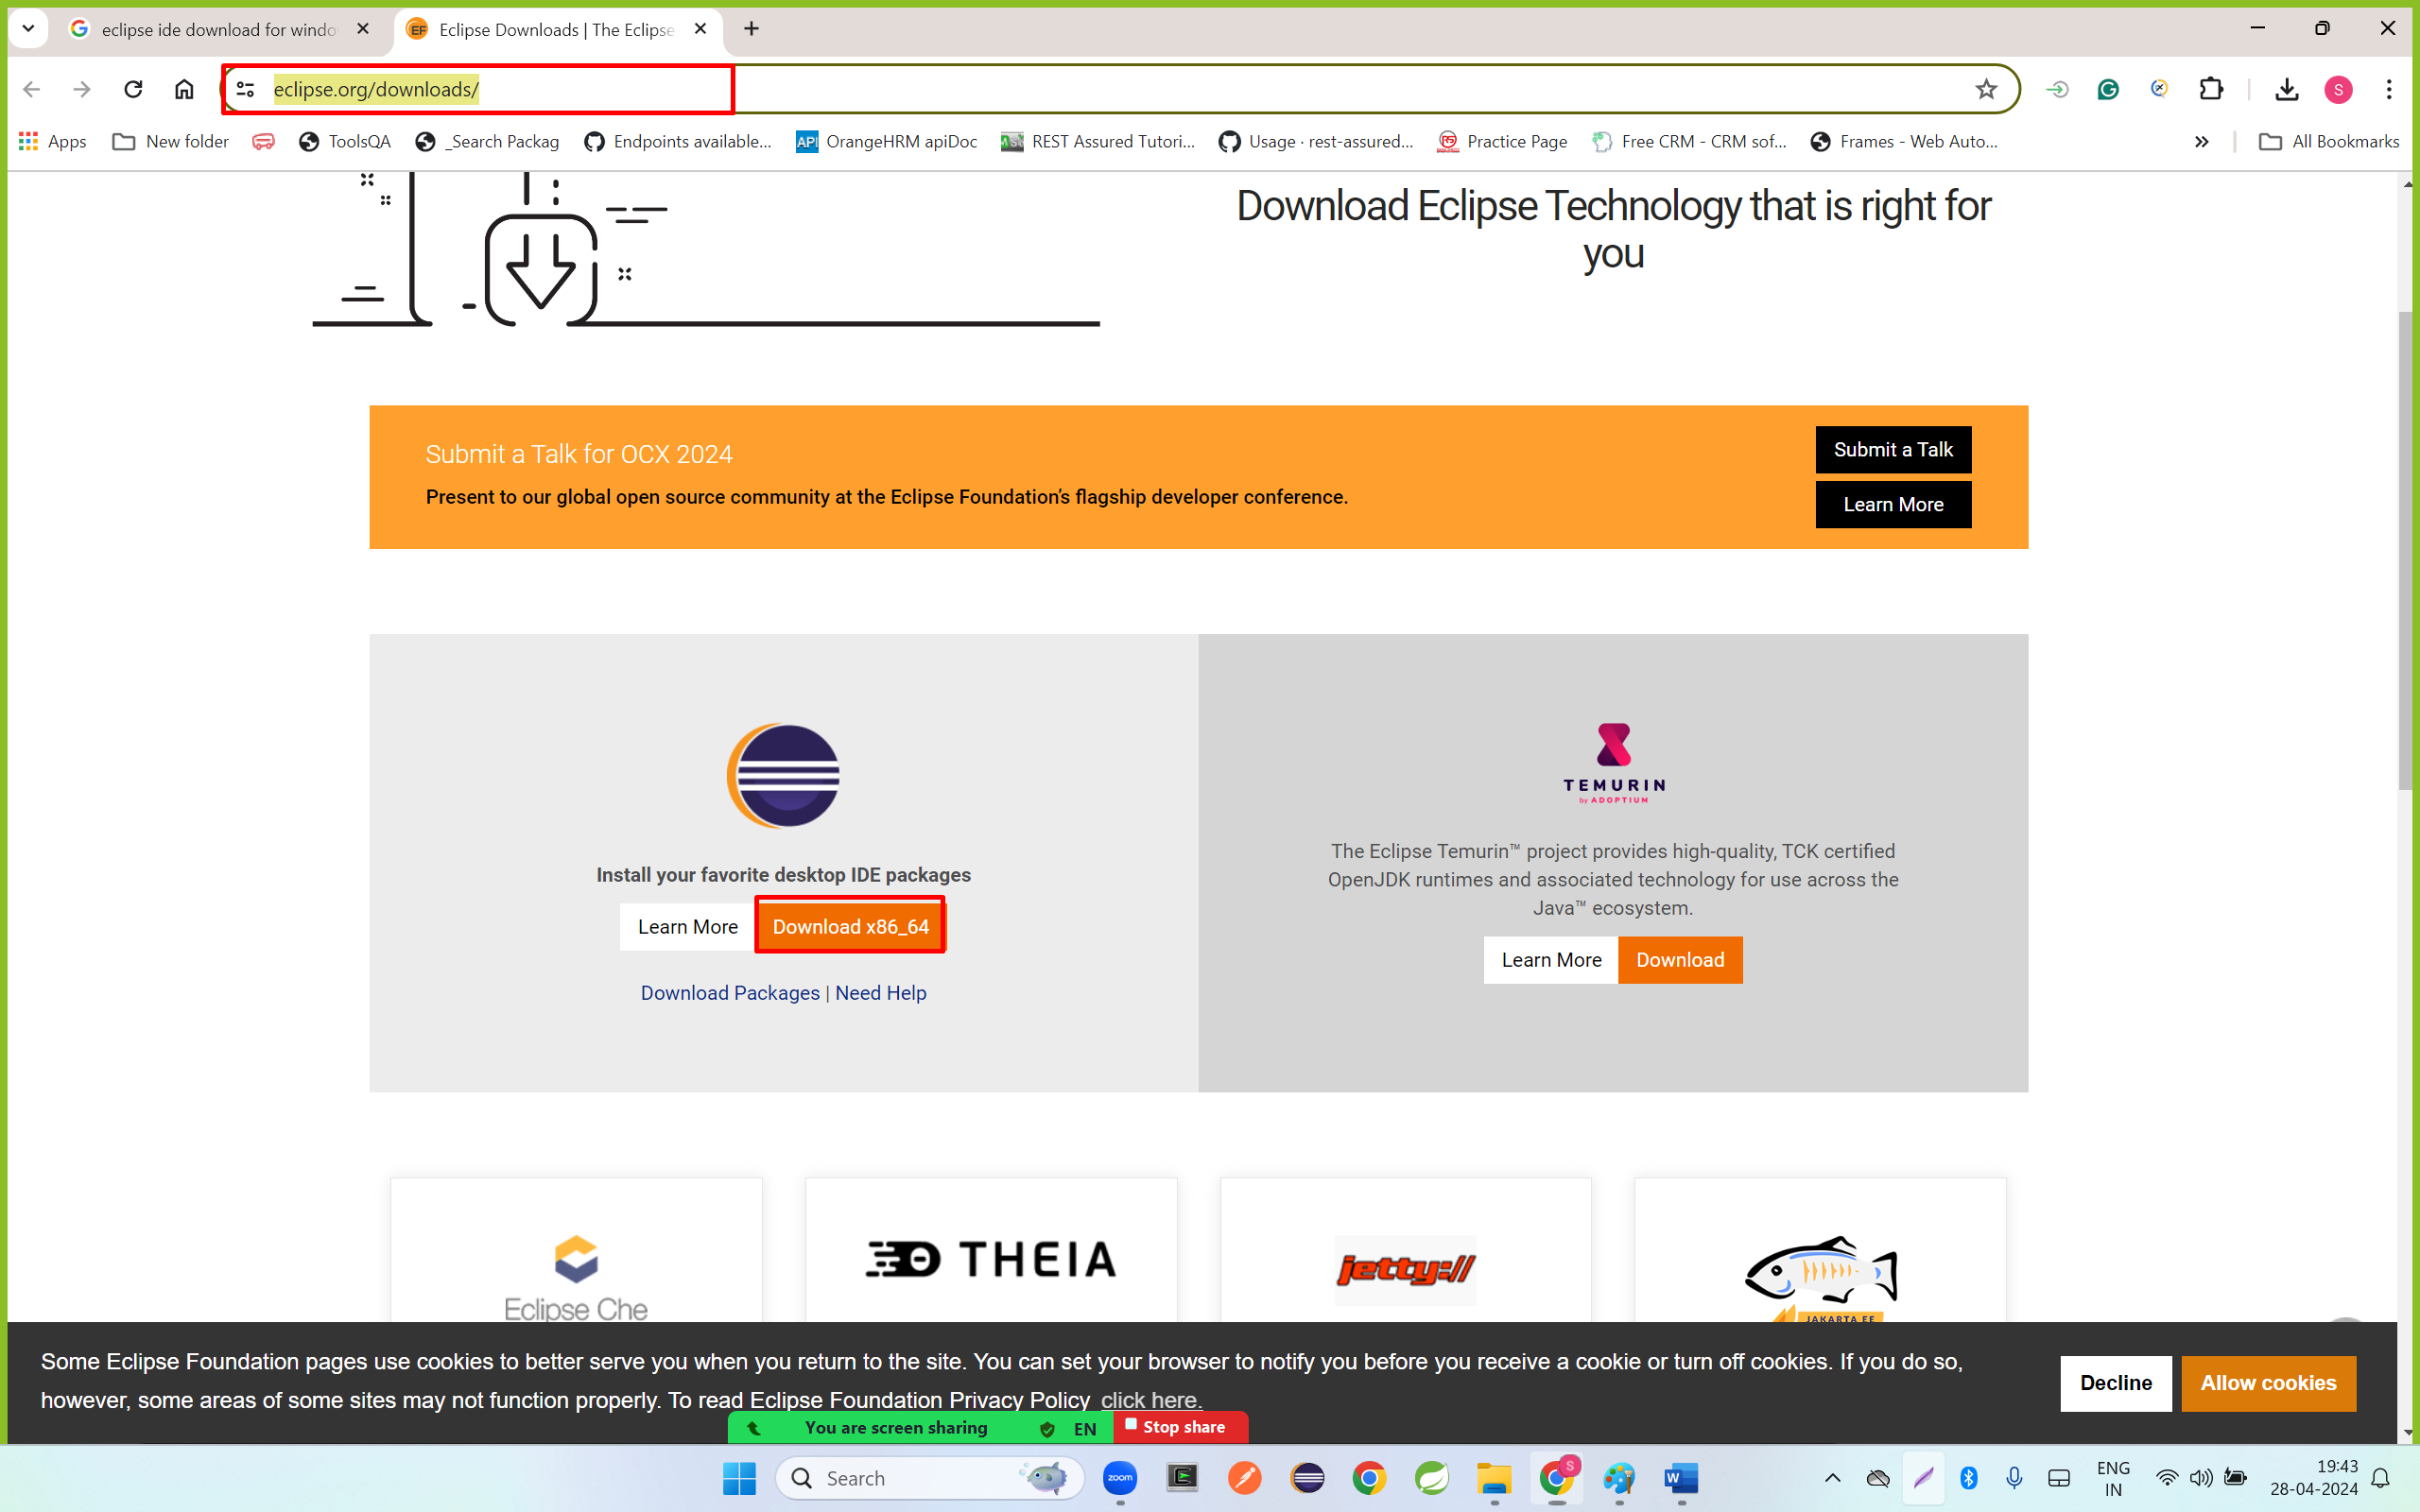

Step 3: click on download button

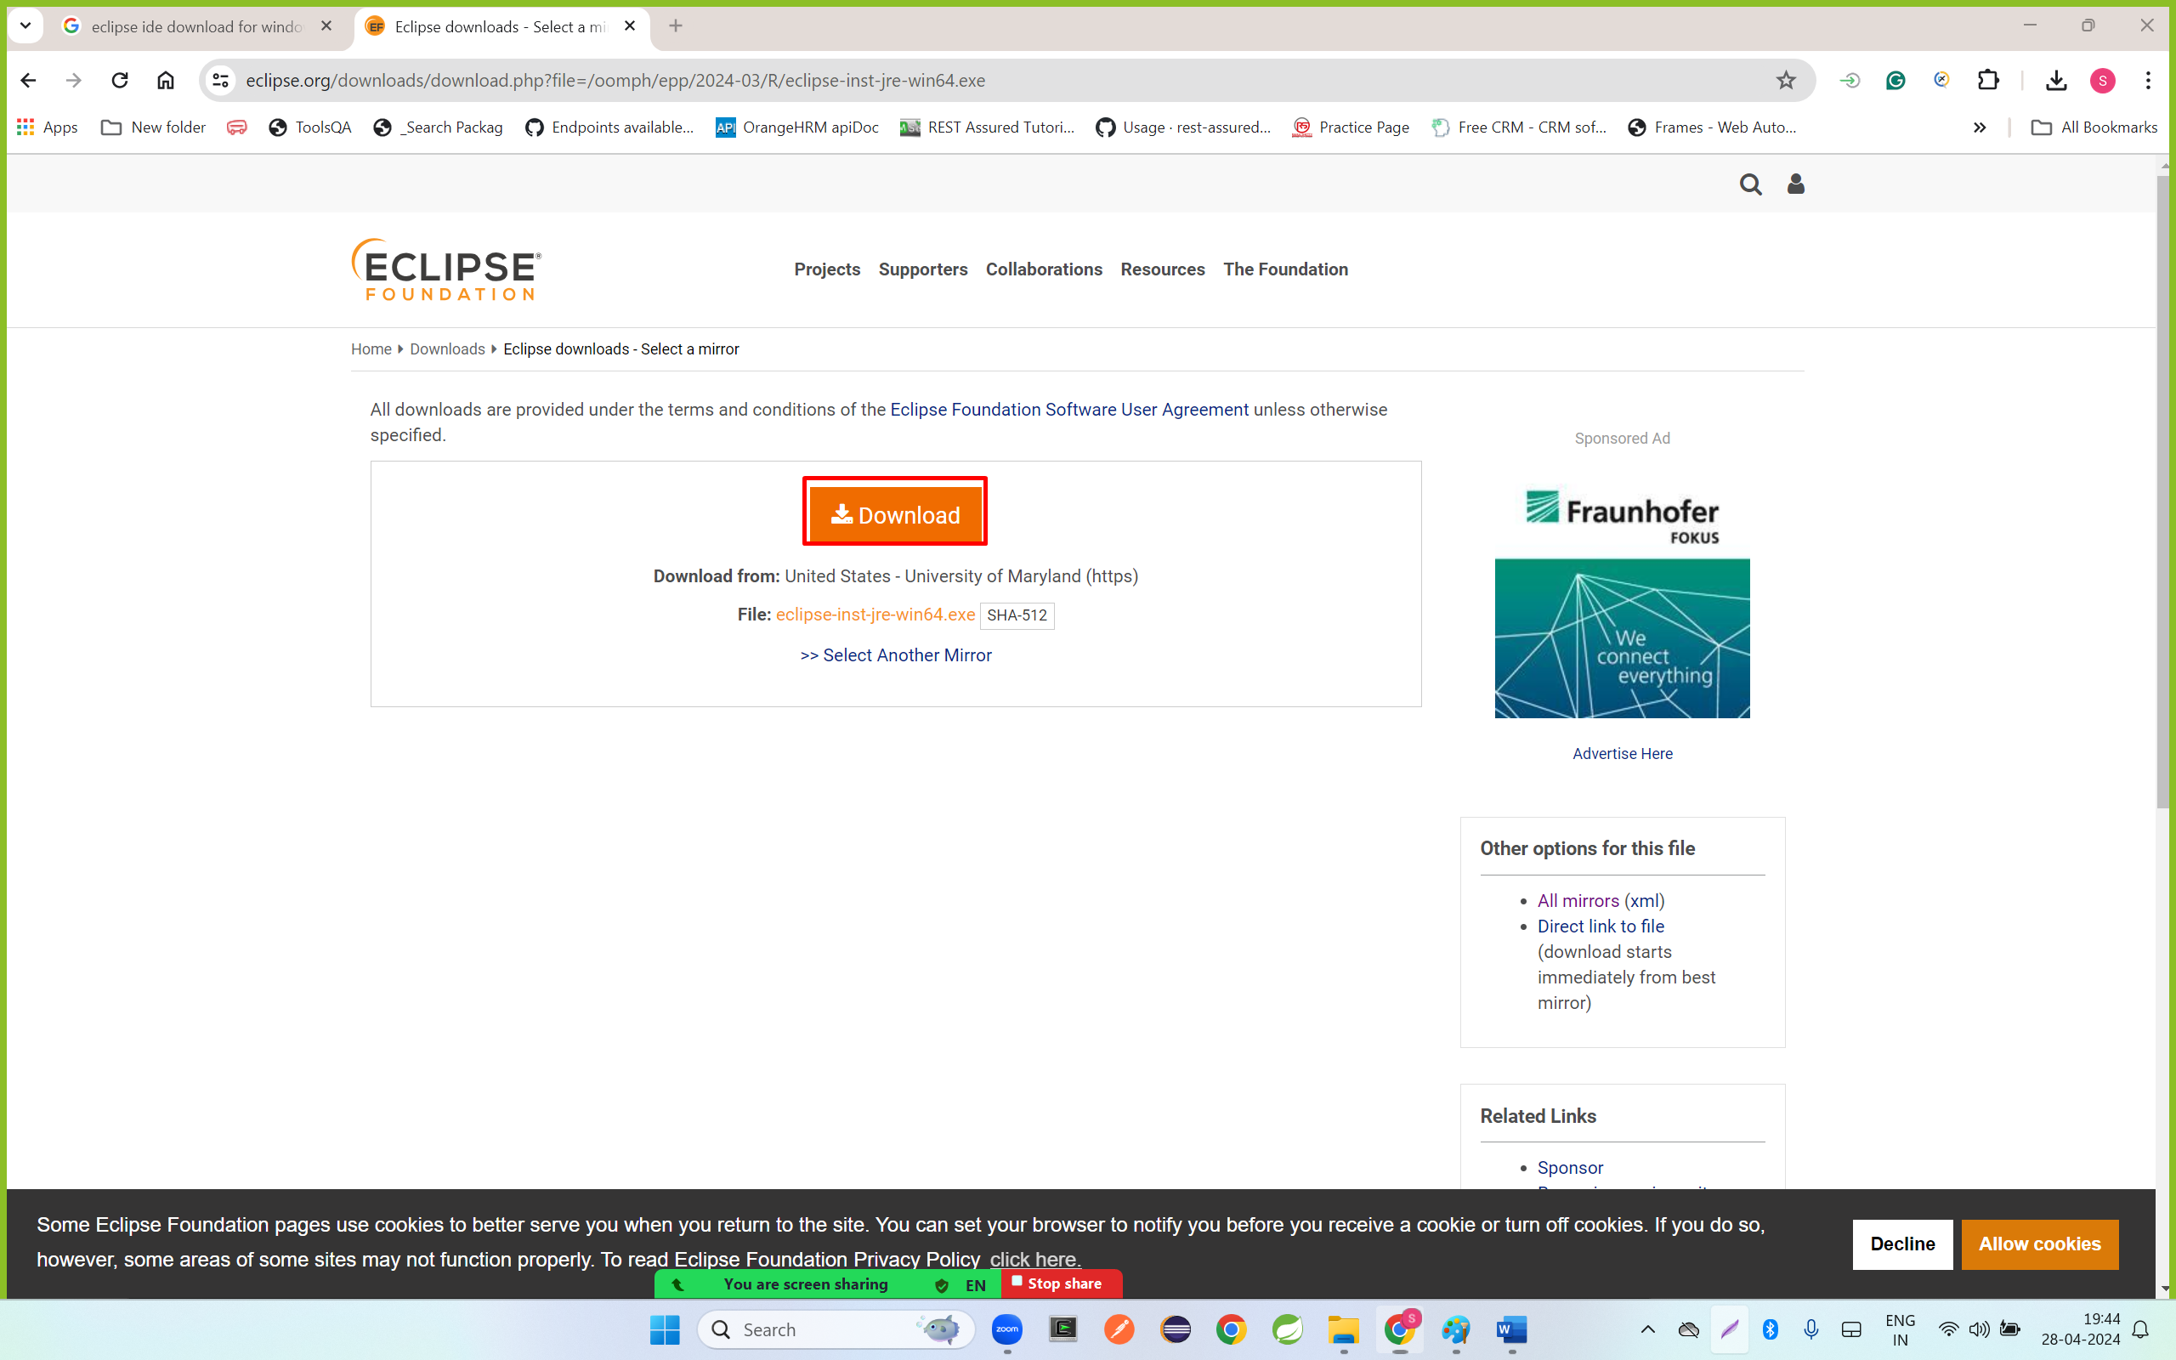

Step 4: click on downloaded Eclipse IDE file

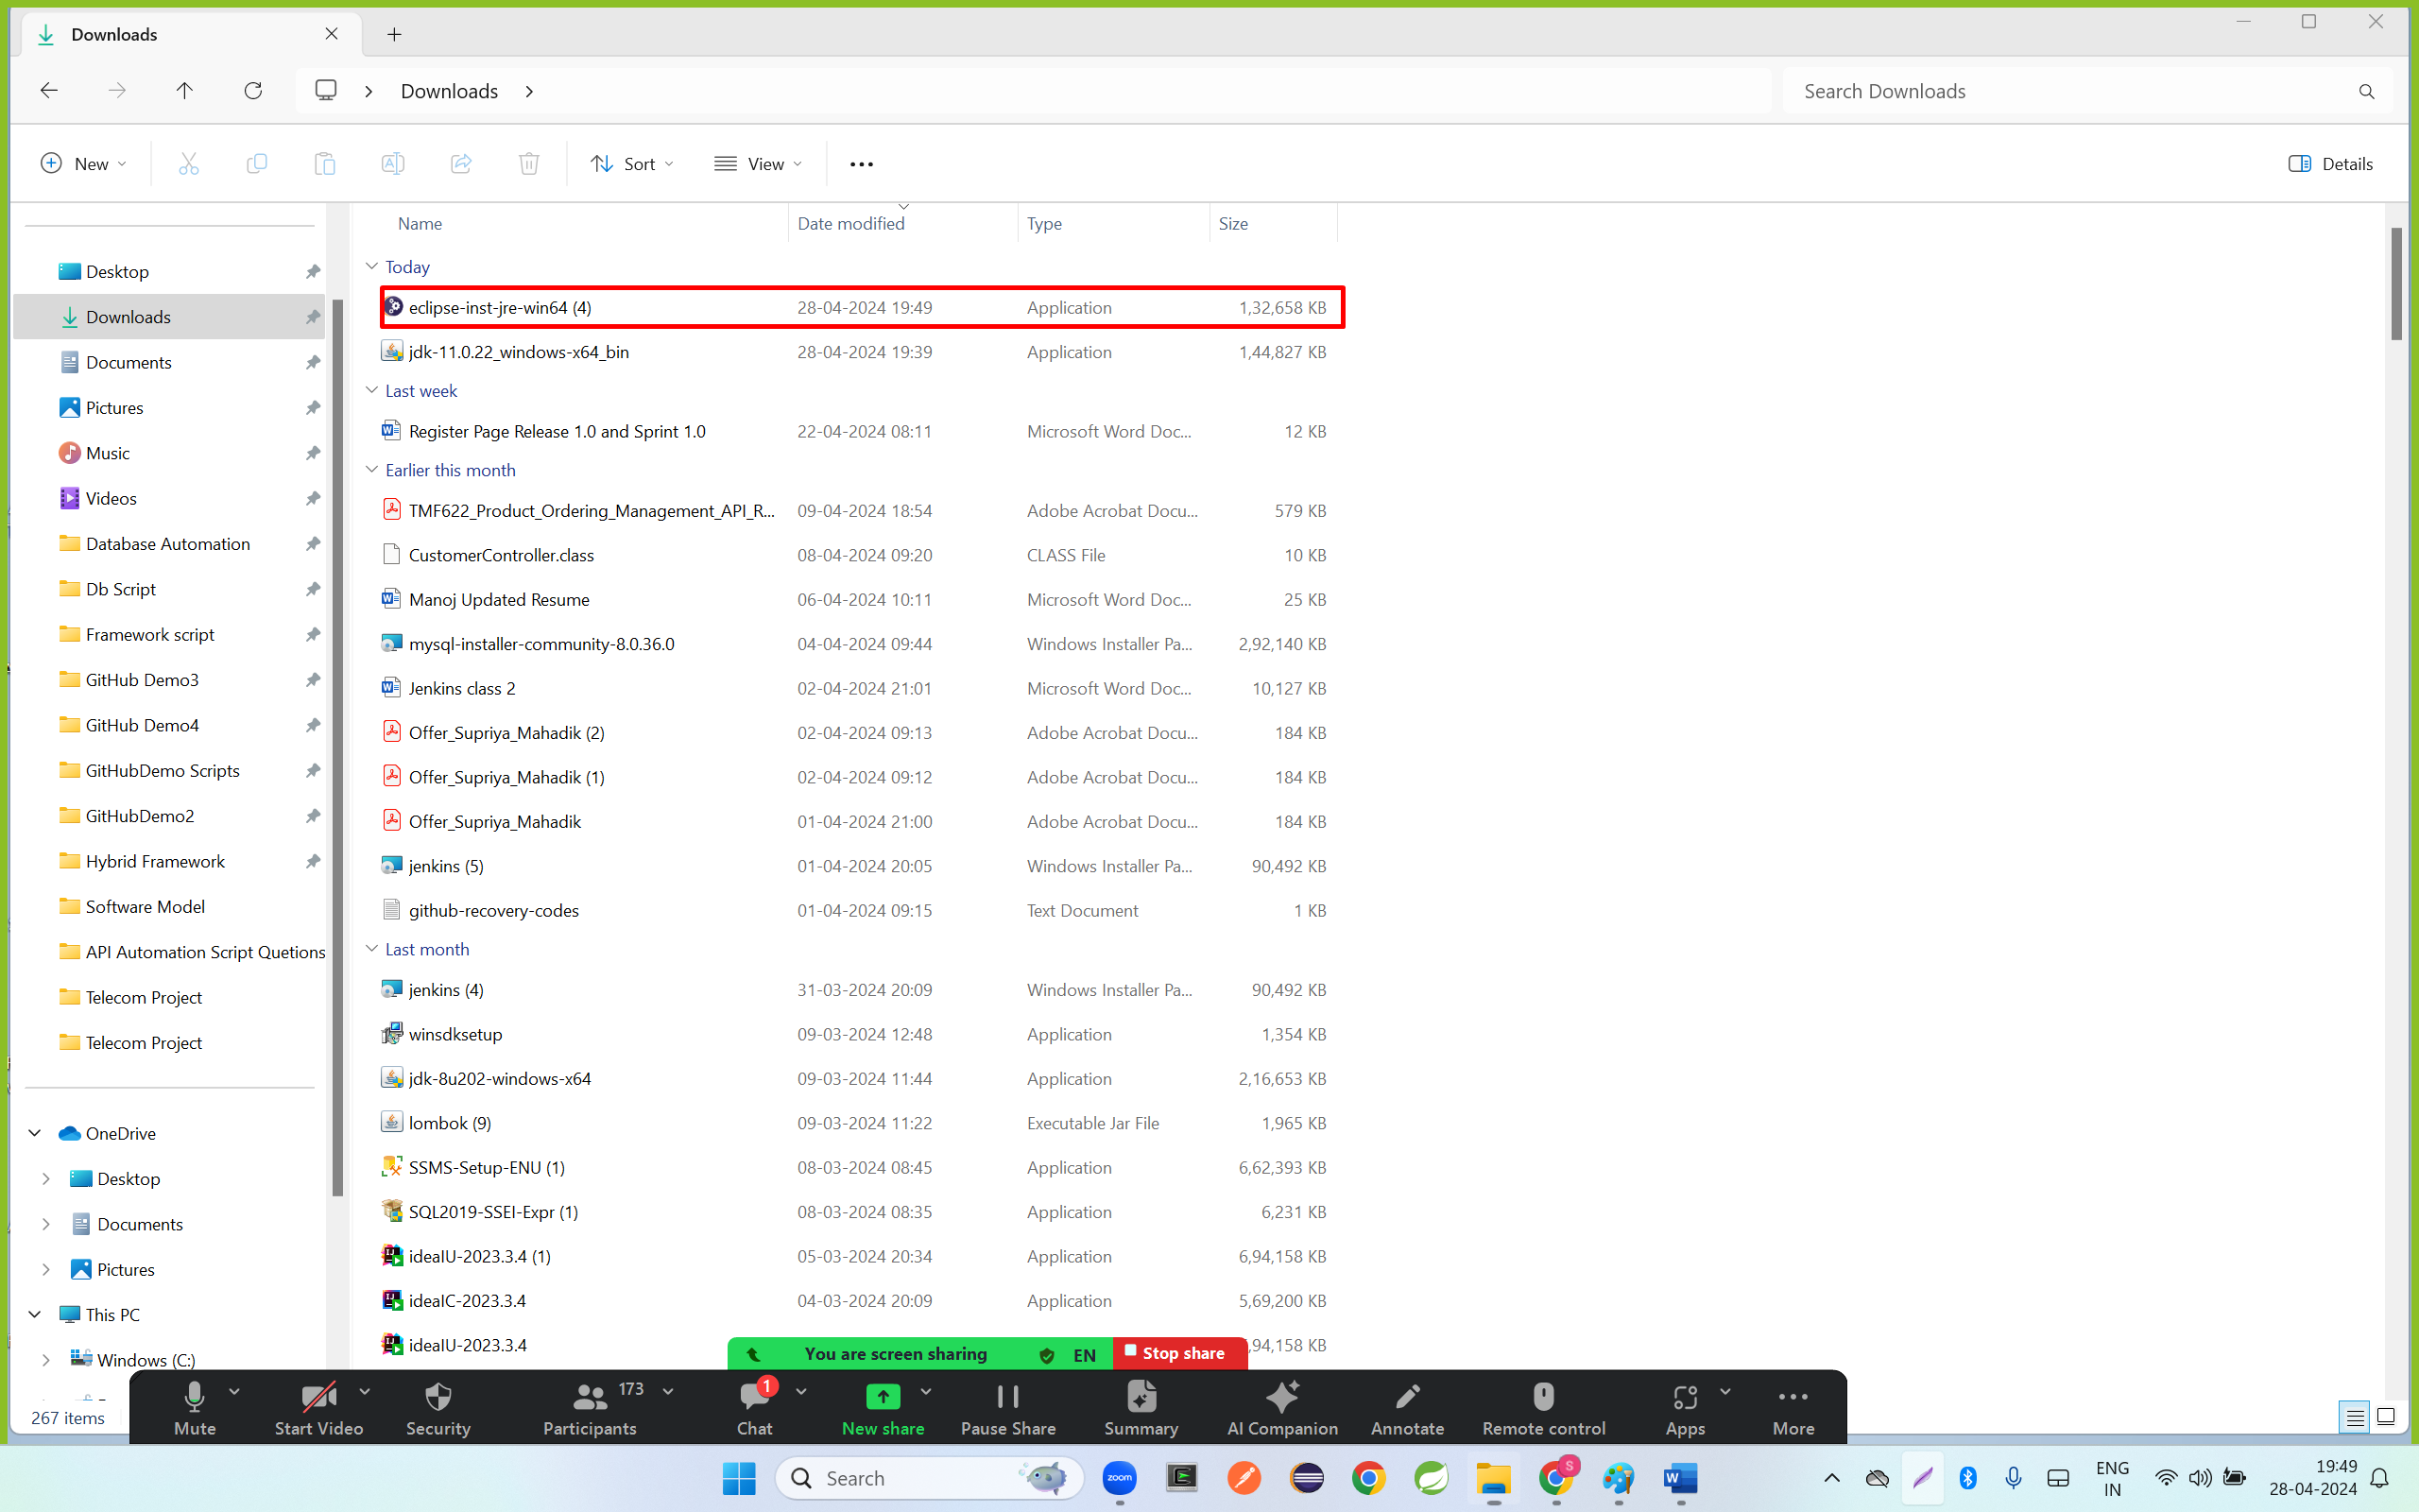

Step 5; click on first link , Eclipse IDE for java Developer

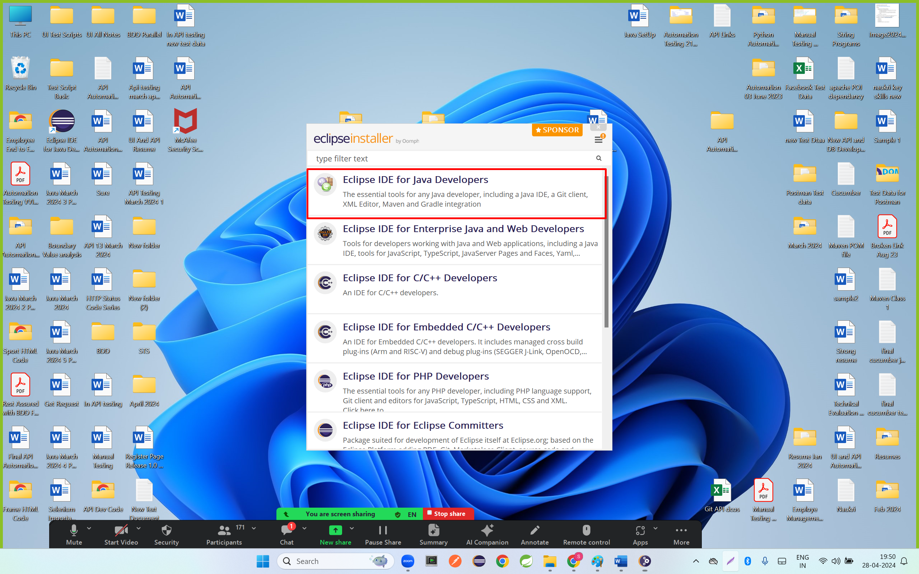

Step 6: click on both checkbox and click on install

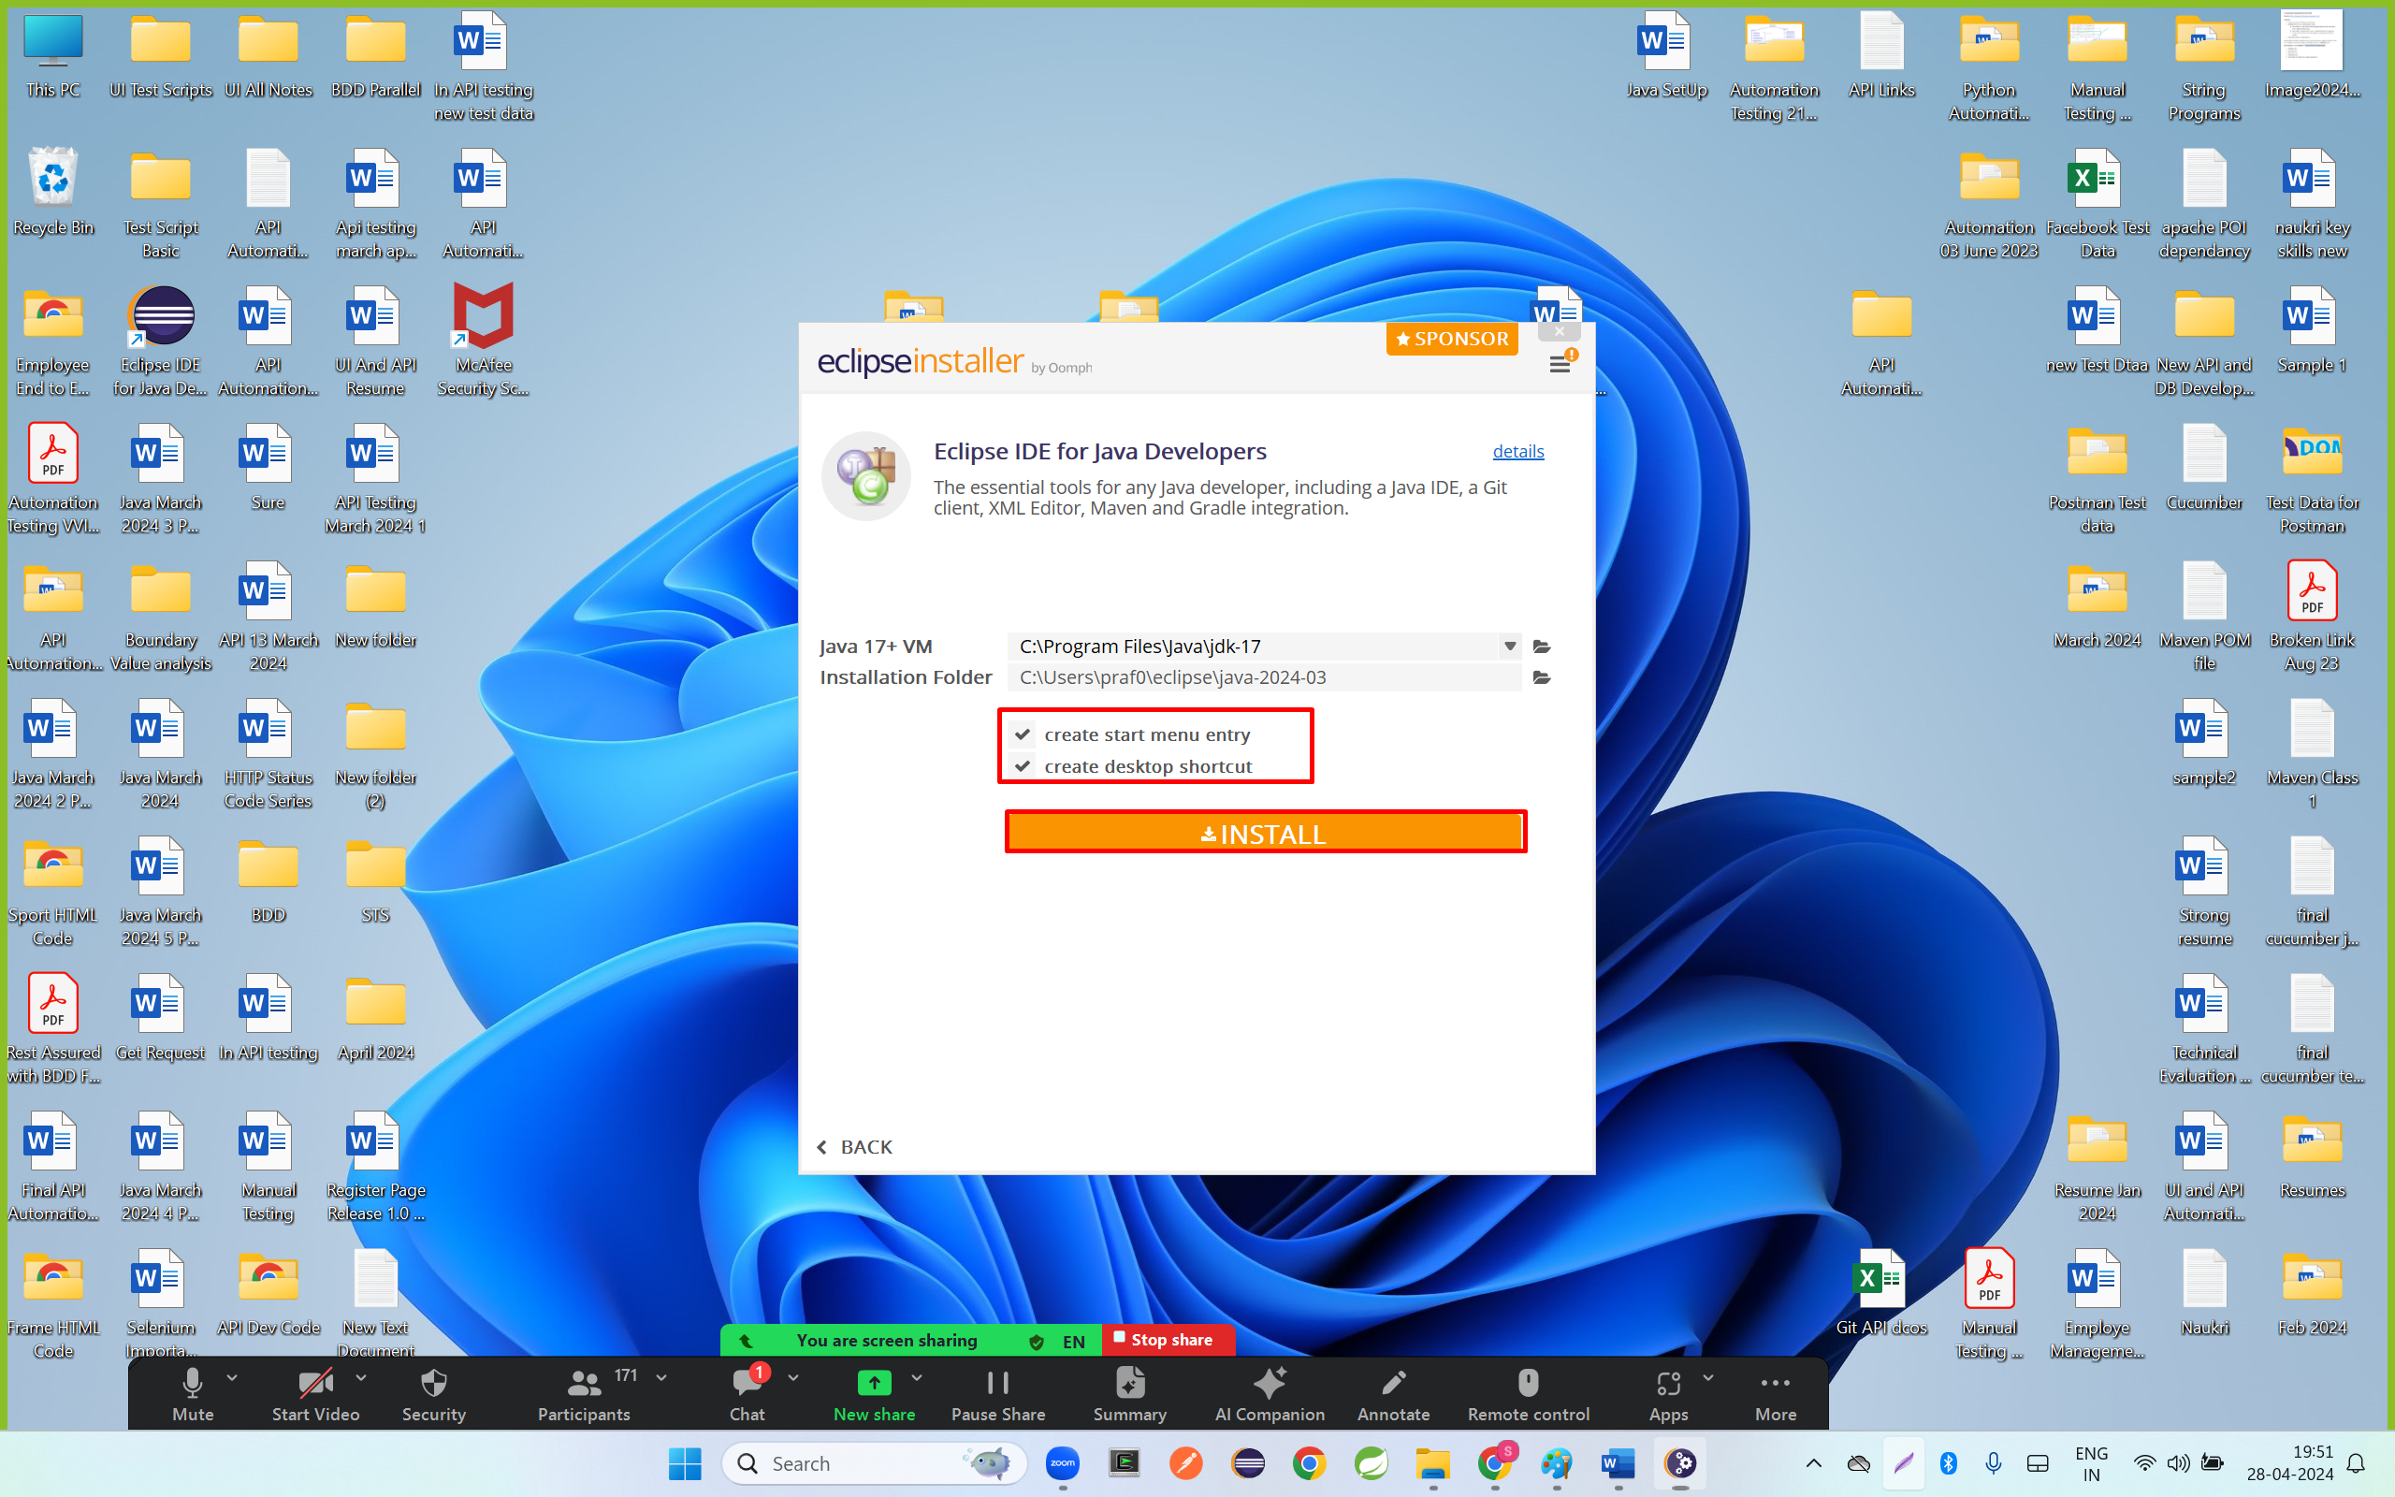

Step 7: click on launch

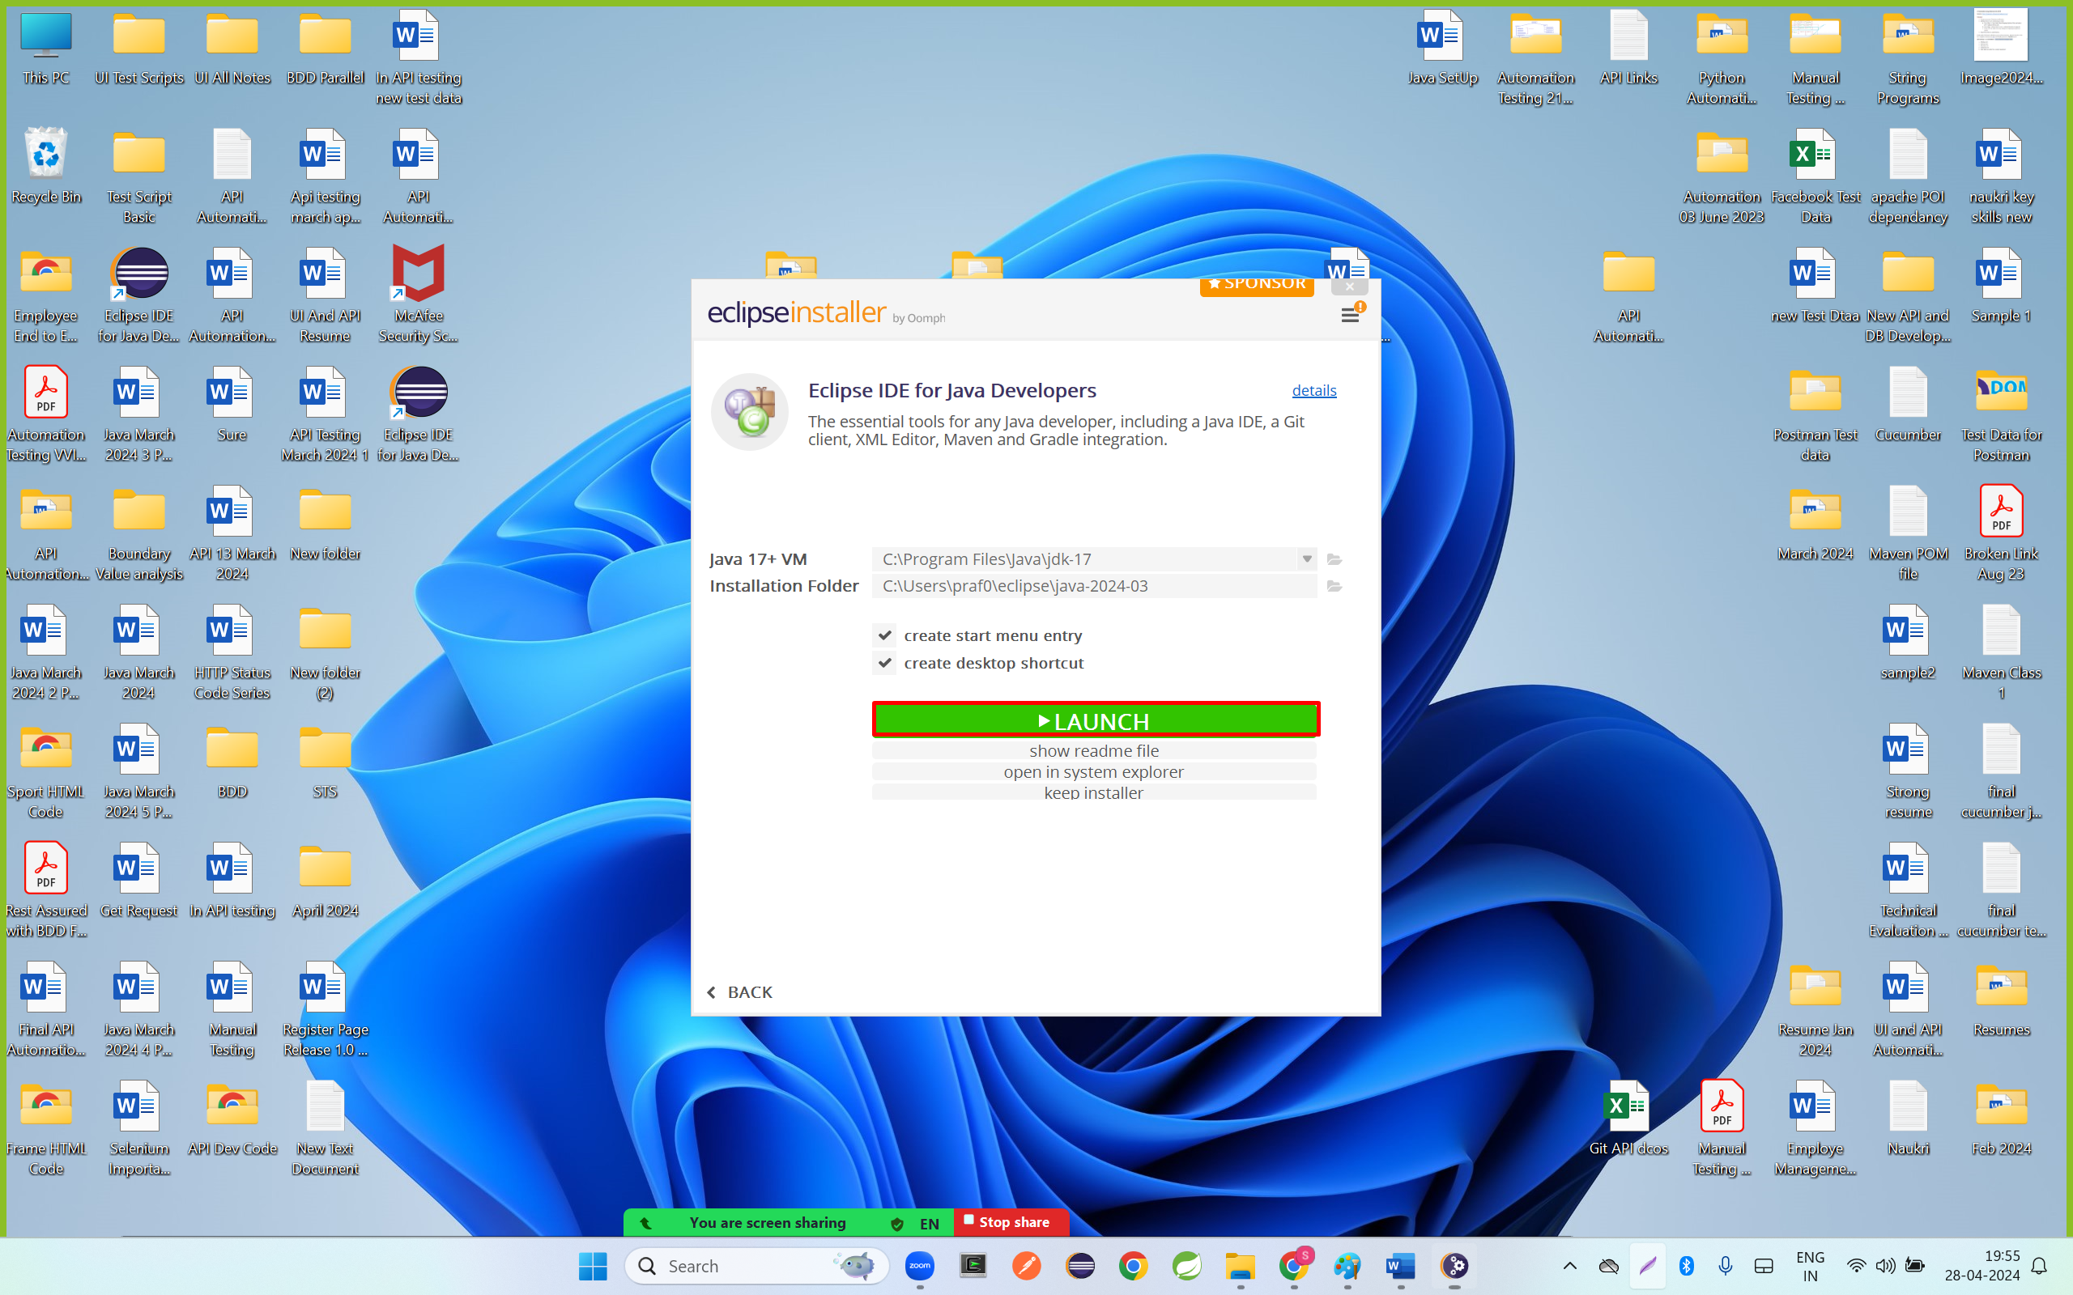

Step 8: click on launch

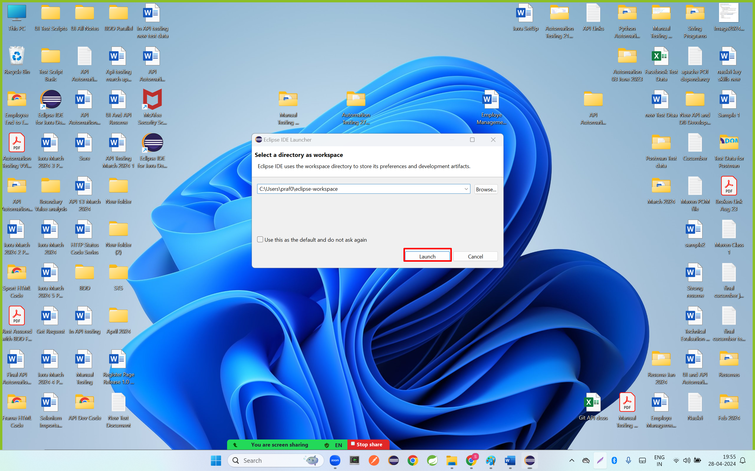

Step 9: click on first radio button and click on proceed button

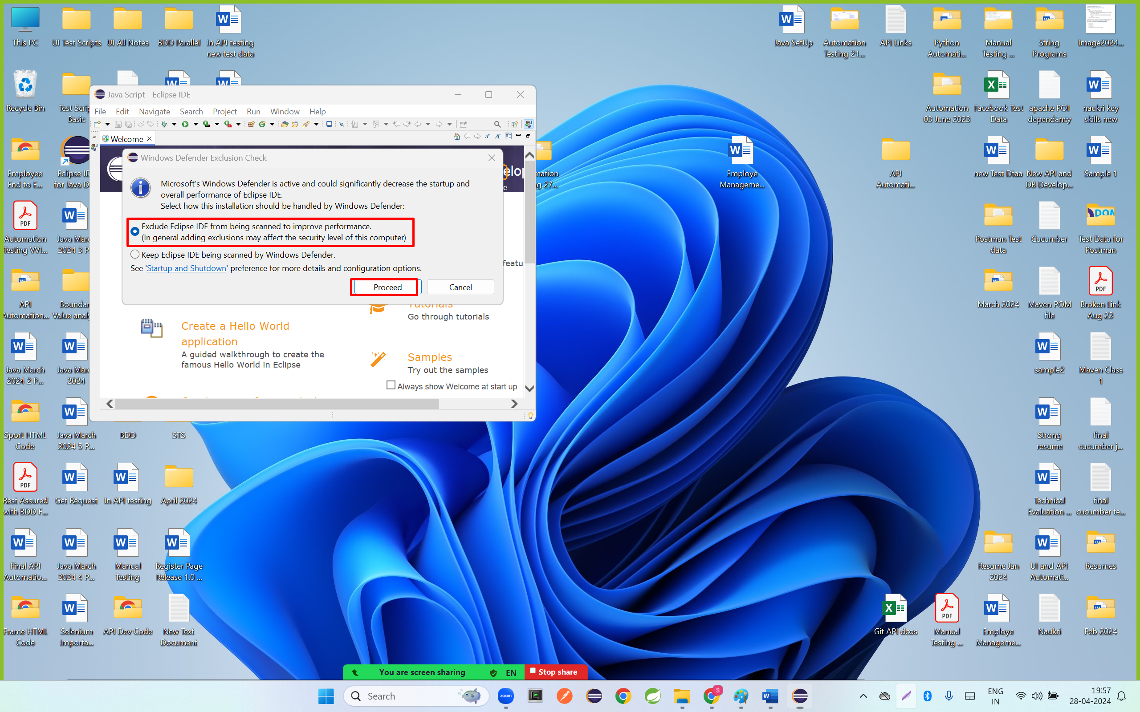

Step 10: click on close button

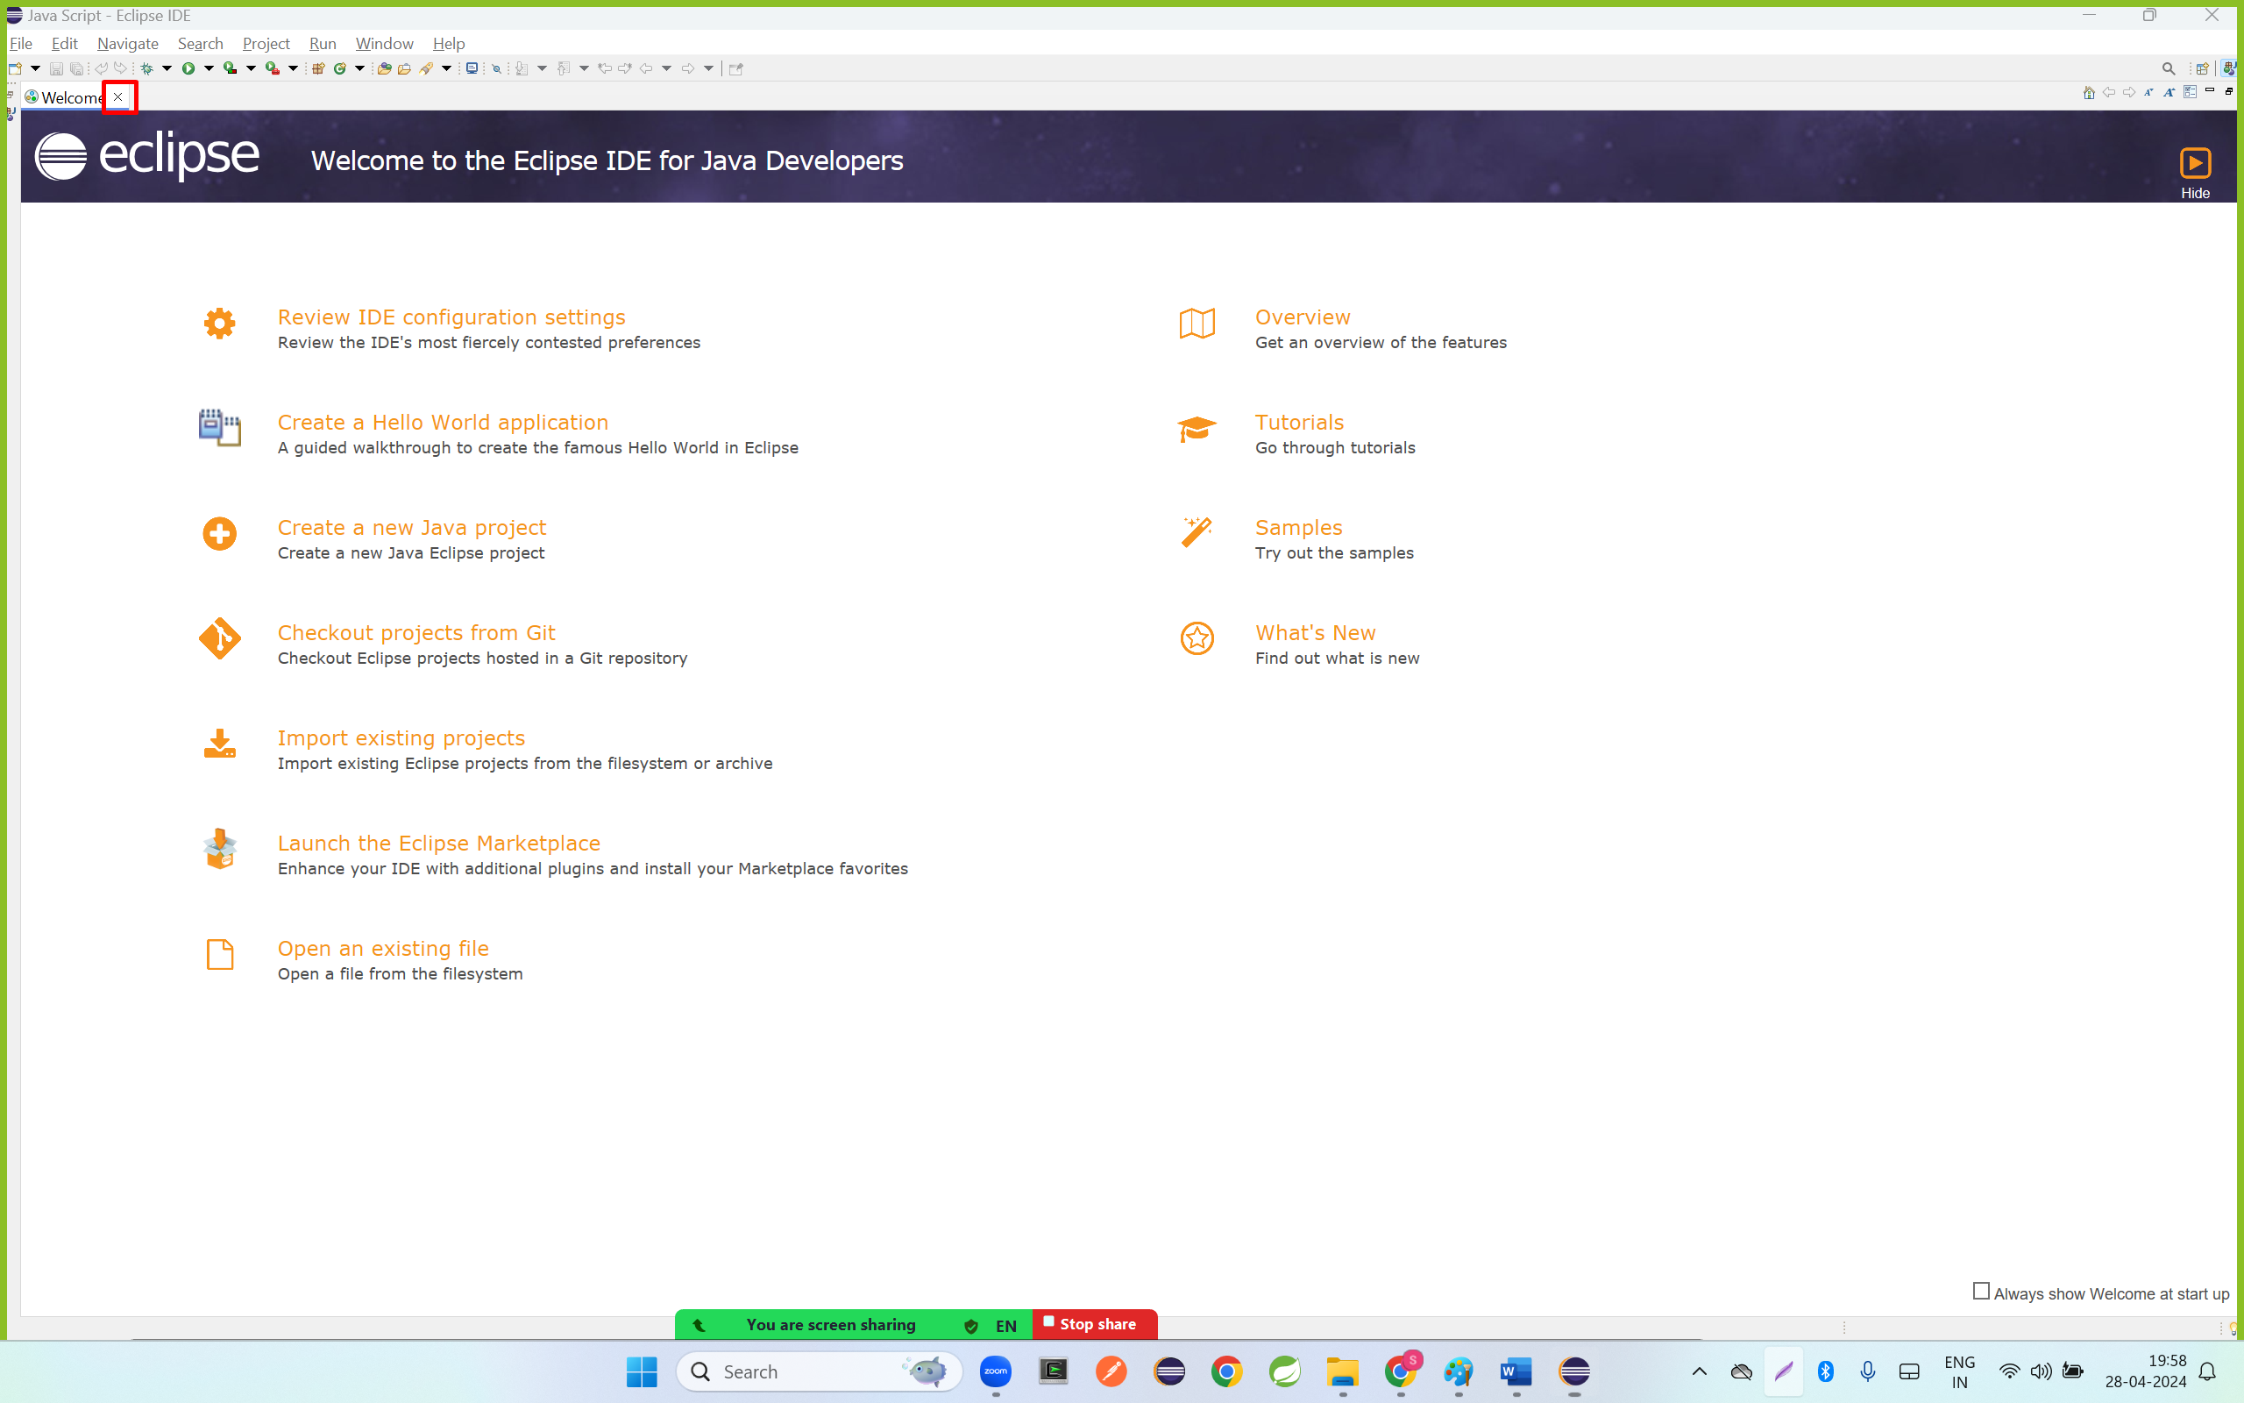

**Create a Java Project**

Step 1 ; click on Java Project

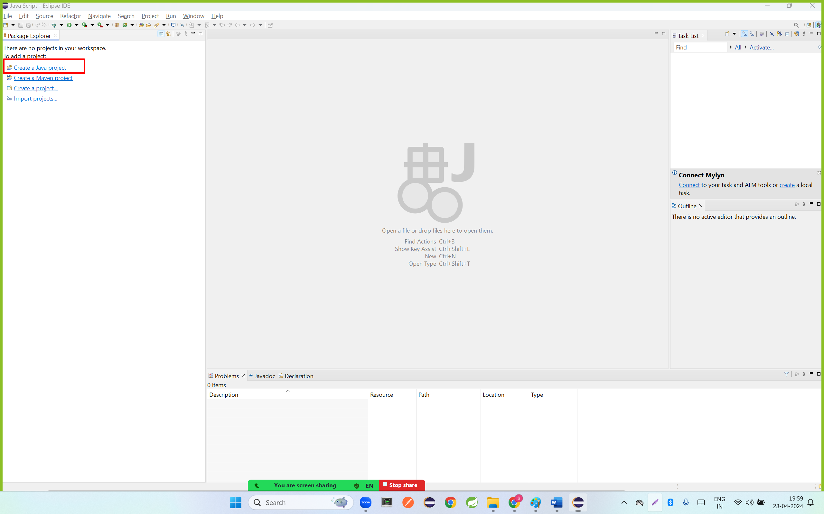

Or

Step 1: click on file – go to new and click on java Project

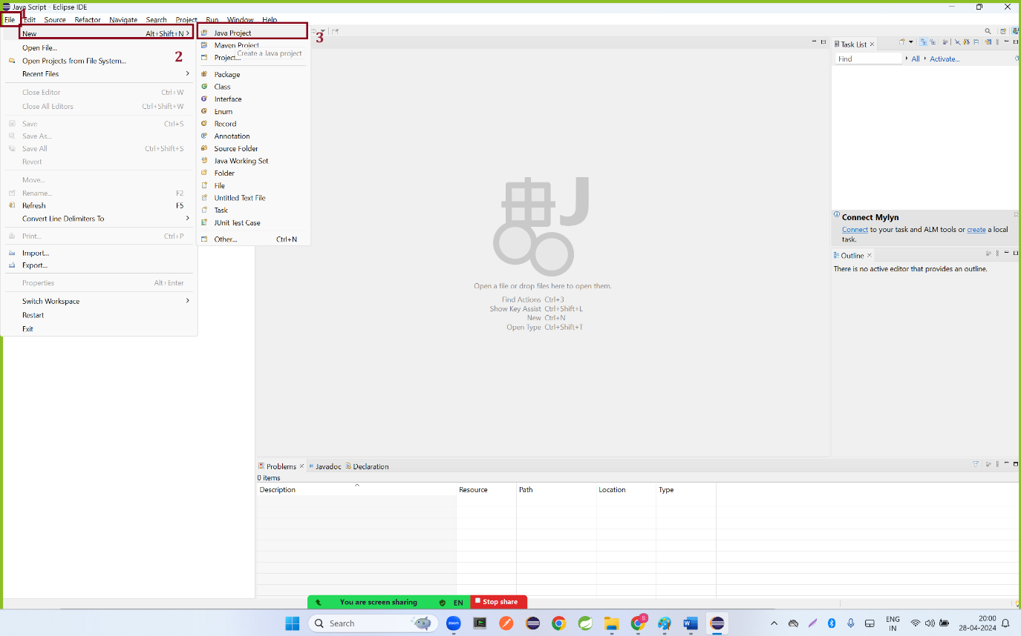

Step 2: Enter the Project name as JavaTutorial and click on finish

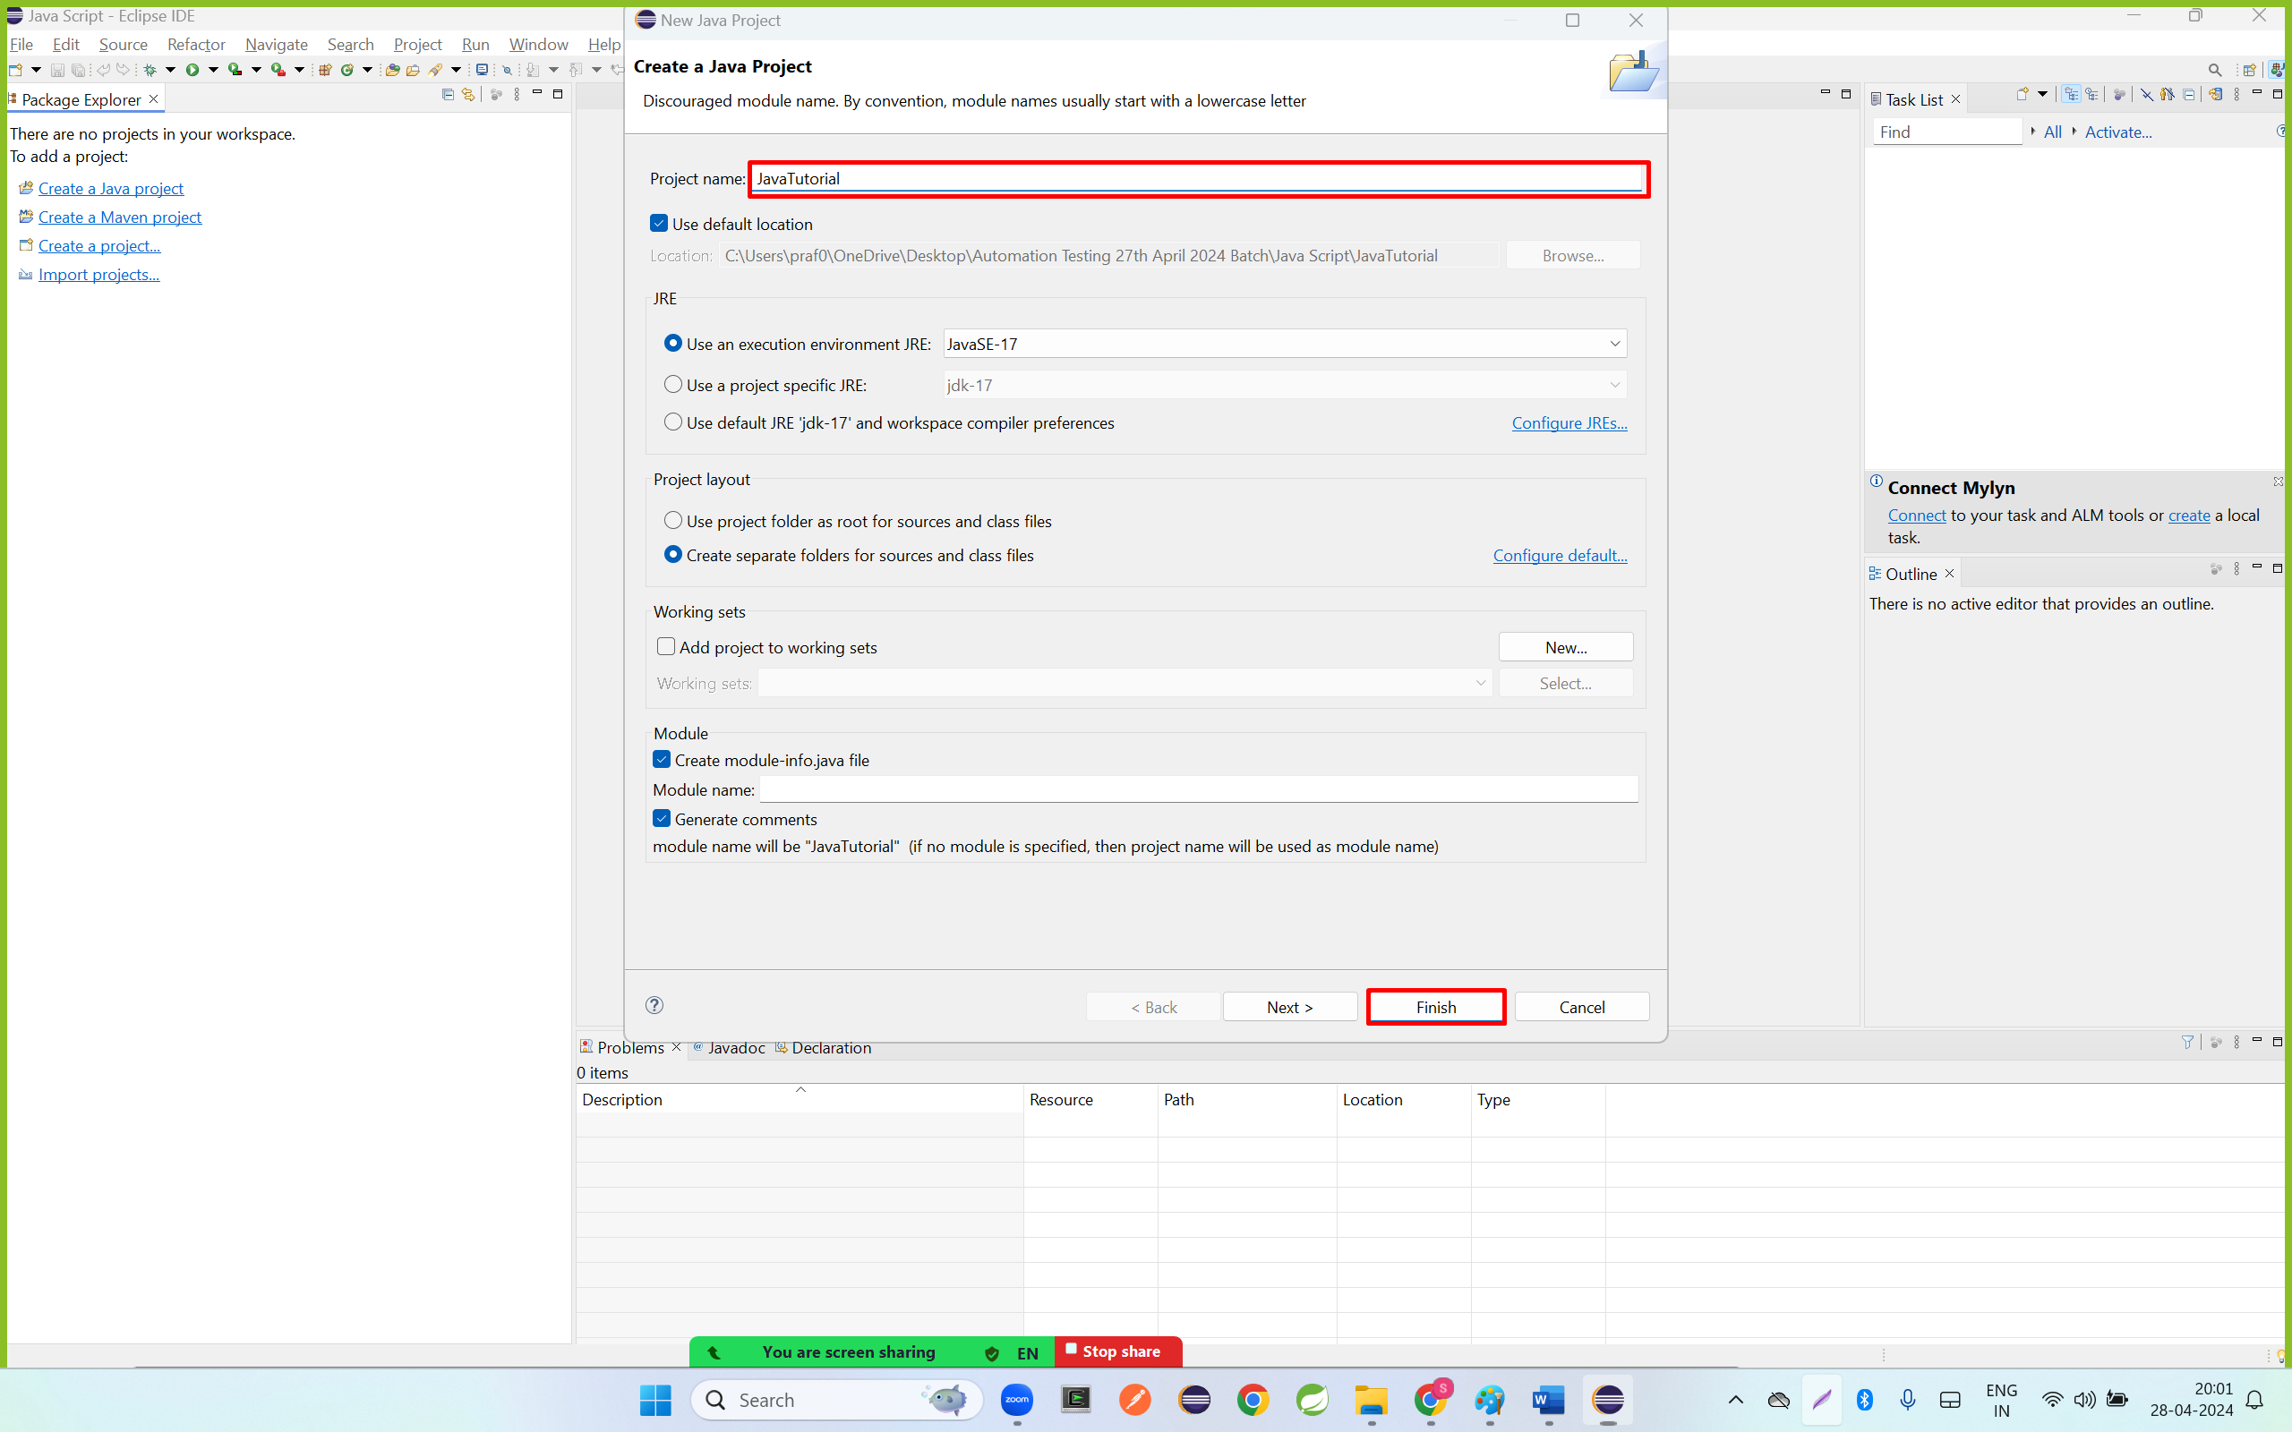

Step 3: click on < symbol

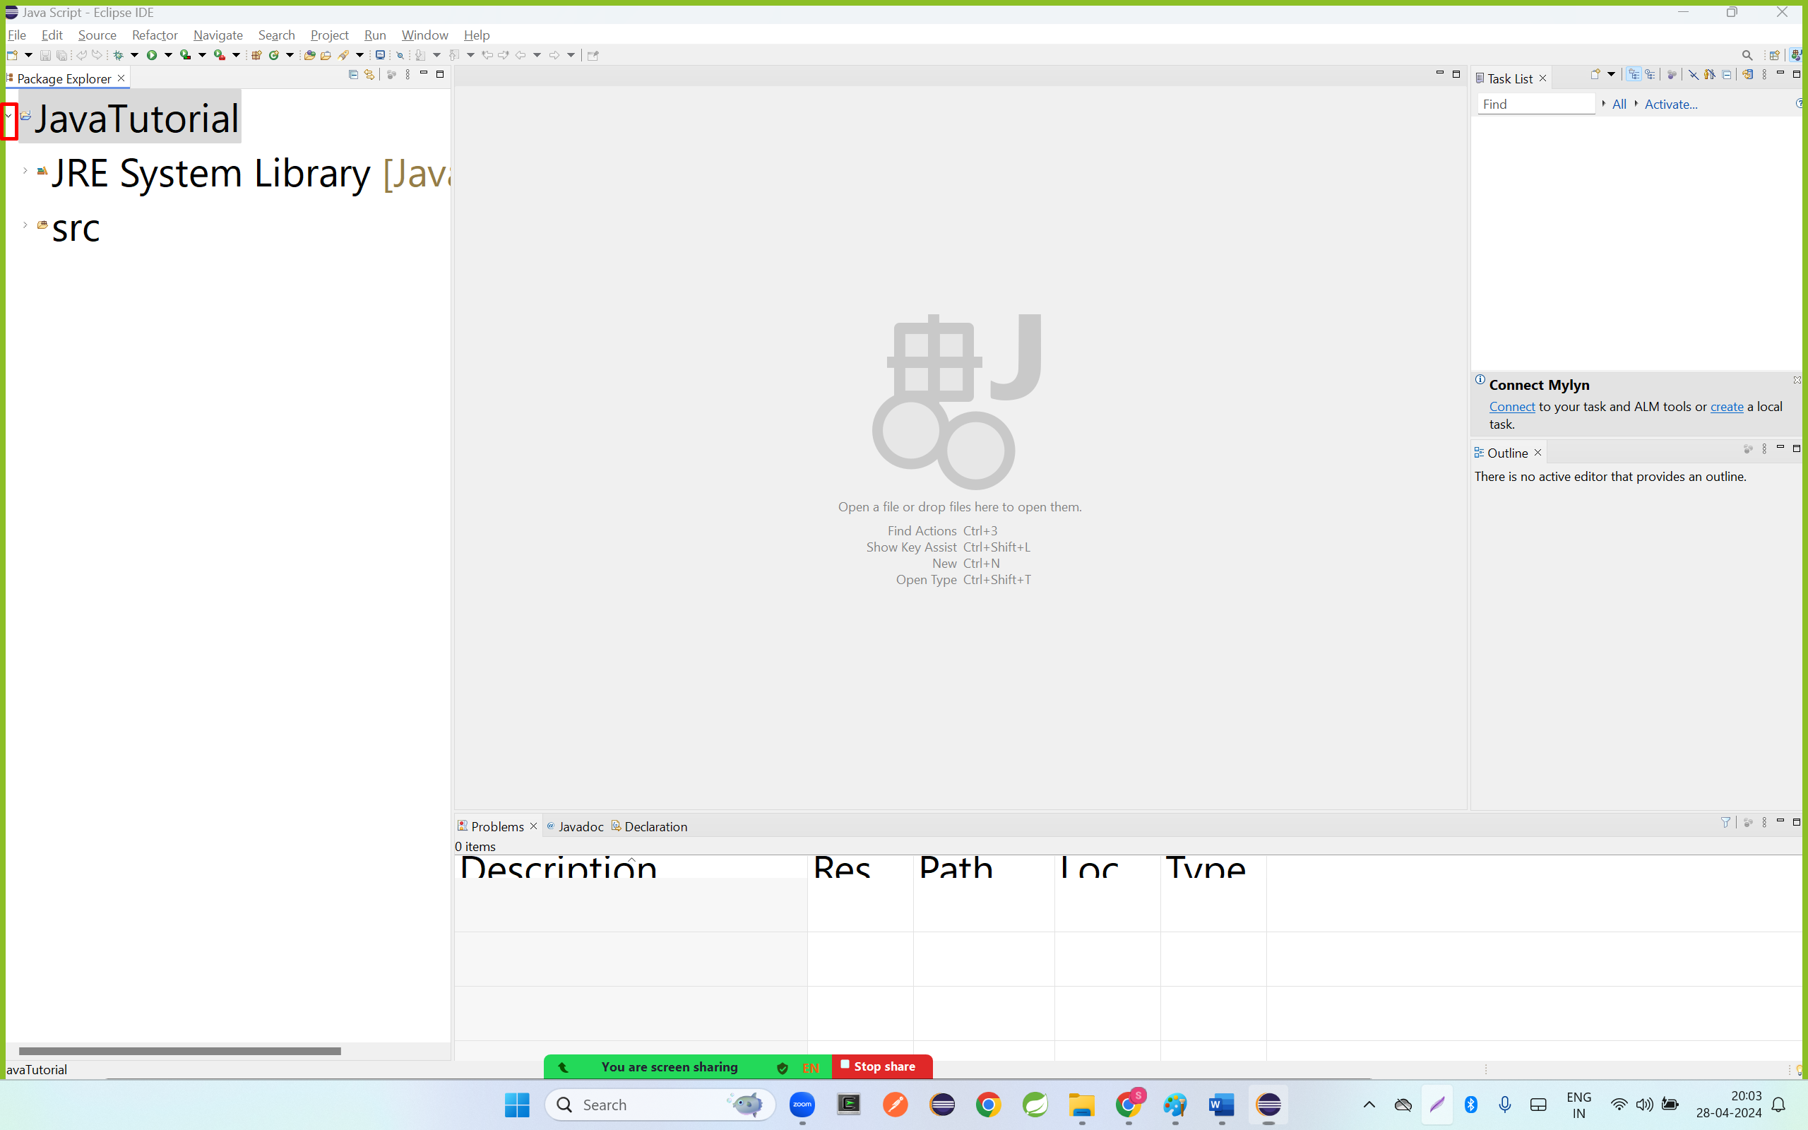

Step 4: Right click src go to new and click on package

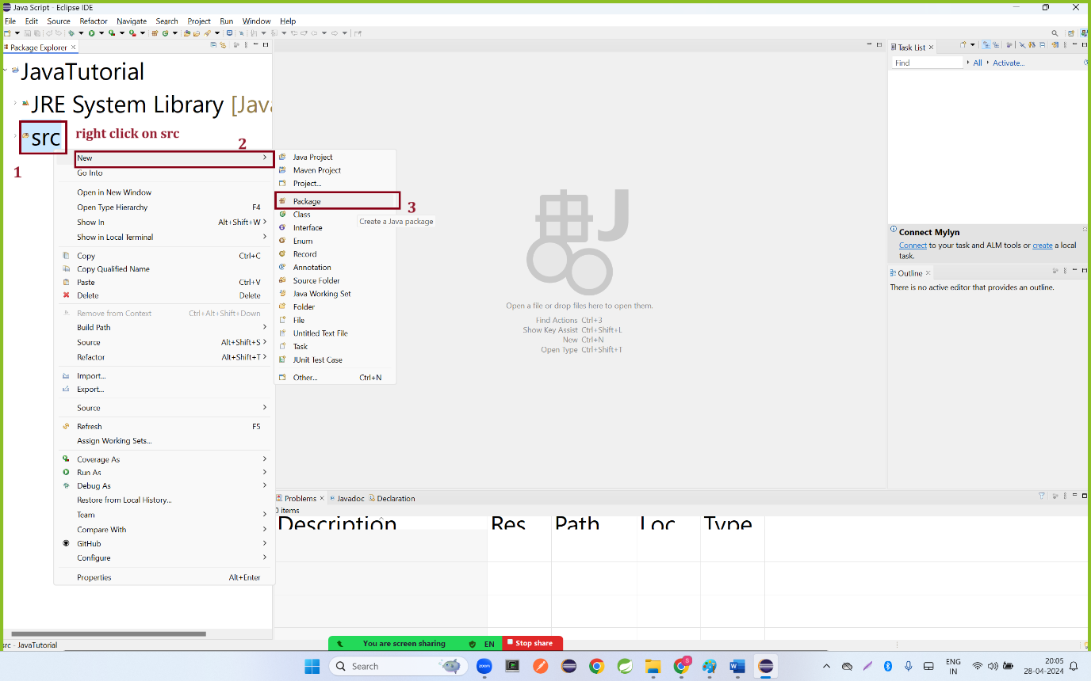

Step 5: enter package name as Tutorial1 and click on finish button

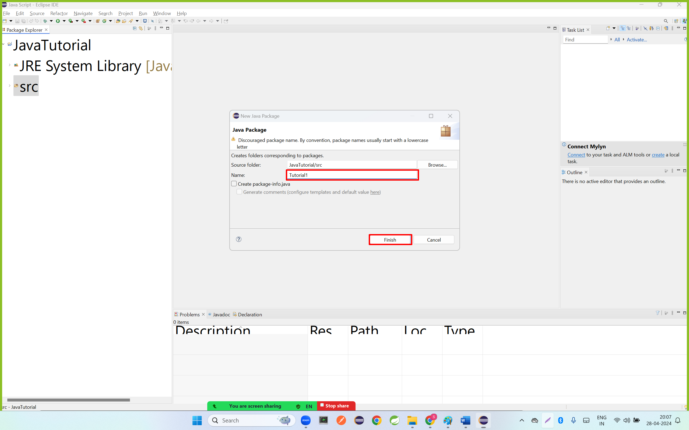

Step 6: right click on Tutorial1 package go to new and click on class

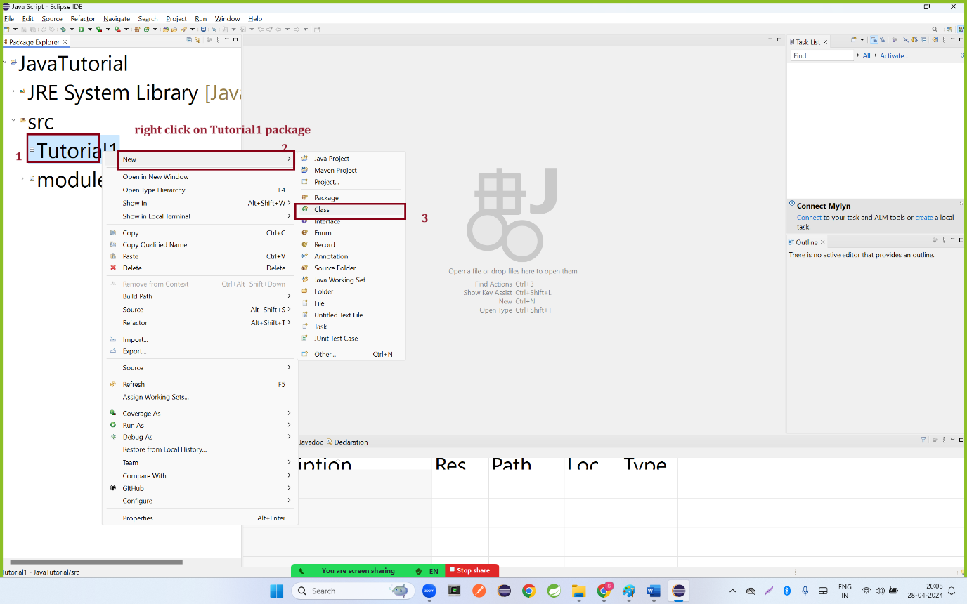

Step 7: Enter class Name as Demo1, select the main method checkbox and click on finish button

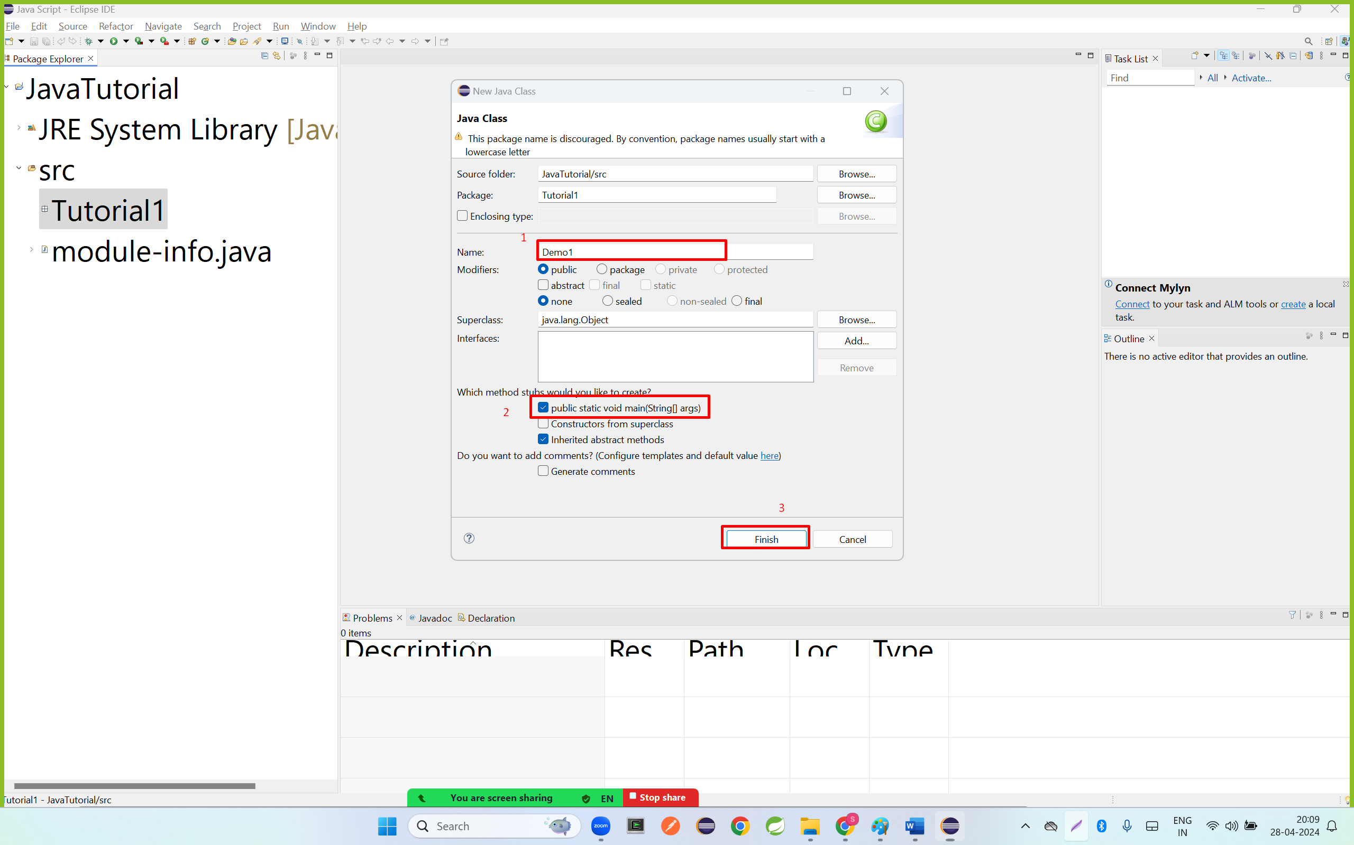

Step 8: Write below code.

|  |
| --- |
| **package** Tutorial1;  **public** **class** Demo1 {  **public** **static** **void** main(String[] args) {  // **TODO** Auto-generated method stub    System.***out***.println("Welcome to automation class");  }  } |

Step 9: right click anywhere go to Run As option and click on Java Application

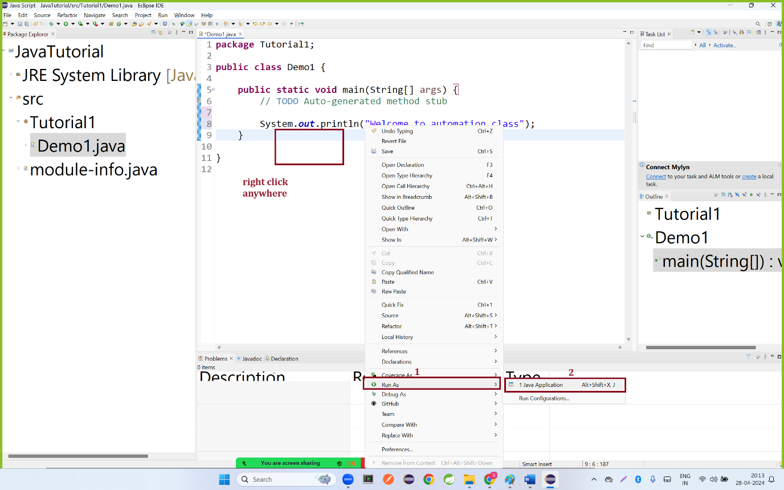

Step 10: select the checkbox and click on OK button

